EVENT DESCRIPTION SHEET
(To be filled in and uploaded as deliverable in the Portal Grant Management System, at the due date foreseen in the system.
Please provide one sheet per event (one event = one workpackage = one lump sum).)
PROJECT
Participant: | [1] - [MUNICIPALITY OF FYLI]
PIC number: | [915725106]
Project name and acronym: | [Network of organizations for Promoting Skills for Participation] — [acronym]

EVENT DESCRIPTION
Event number: | [Work Package 8]
Event name: | [Local Awareness Raising Campaigns in Greece (LARC)]
Type: | [desk research, street debate, round table, focus group, podcast, dissemination event]
In situ/online: | [in-situ]
Location: | [Greece], [Fyli]
Date(s): | [Desk research: 13 February 2025;  Street debate: 23 October and 10 November 2025;  Round table:25 November 2025  Focus groups: 12, 19 and 22 February 2026  Podcast: 27 May 2026  Dissemination event: 09, 12,15 June 2026 ]
Website(s) (if any): | FB: https://www.facebook.com/SocialServicesFyli/posts/pfbid02n5kR16PhcnRNpiVzfGwpF7PUhrmKy6VK1YpXx1SA33PrApBZD2qgA2NnYoRNkqdNl  Official webpage:  https://fyli.gr/not-skip-network-of-organizations-and-towns-for-promoting-skills-for-participation/
Participants
Female: | 188
Male: | 174
Non-binary: | 0
From country 1 [Greece]: | 362
Total number of participants: | 362 | From total number of countries: | 1
Description
Provide a short description of the event and its activities.
LARC 1: Desk research
The analyses resulted in several national greek good practices that successfully use culture, education, and community engagement to strengthen democratic participation and active citizenship.
The most important initiative that was analyzed was the “Youth Parliament”:. The research highlighted initiatives such as Putting Participation into Practice is an educational program organized on a large scale by the Hellenic Parliament Foundation for Parliamentarism and Democracy, The main objectives of the program are to familiarize adolescents with the principles and values ​​of democracy, with the functioning and role of Parliament, as well as to train them in democratic practices and to activate them in issues that concern the school, the community, and society.
Also, another important good practice that was analyzed was the “Youth Climate Awareness and Leadership Program” that is taking place in Crete island. This voluntary initiative is a two-tier program, serving the same goal under the EU’s Climate Pact, i.e. leveraging climate awareness among youth and showing up their leadership skills. The presentation of this practice during the duration of “NOT SKIP” project had a certain impact a many groups have asked for more info about this initiative and we have gave access and contact details with the organizers in order to disseminate more their actions.

COMMUNICATION AND DISSEMINATION LINKS:
https://cervprojects.wixsite.com/notskipproject/about-7?pgid=matwzol6-bbd81131-b6e7-4d85-a90a-6fcb60bc8628

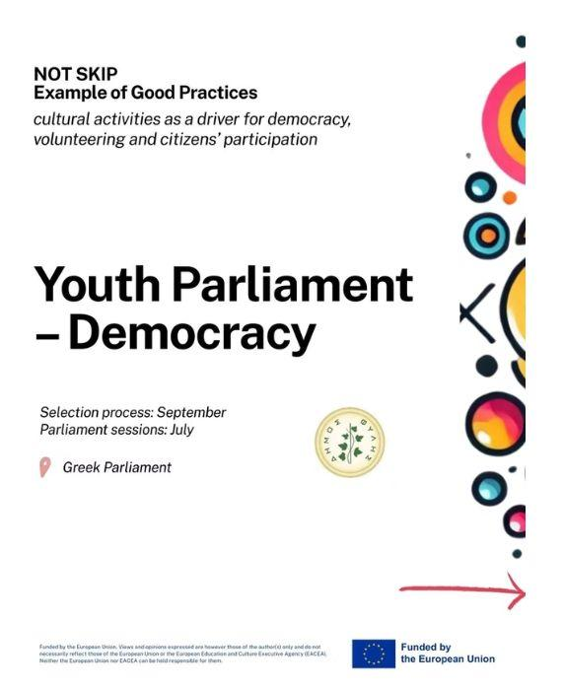

LARC 2: Street debate
The local activity featured the creation of a Tree of Peace, a symbolic installation designed to promote unity, dialogue, and hope. Participants were invited to write their ideas, messages, or wishes for peace on colorful paper leaves and place them on the tree, creating a collective representation of shared values.
Two street debates were organized. The first took place at the 4th Gymnasium of Ano Liosia (Zofria), in collaboration with the school, local media, and the Cultural Association of Zofria. Around 200 participants, mainly students aged 13–18, actively engaged in the activity. The second event was held outside the Hasia Town Hall, attracting approximately 50 participants, including master's students, local stakeholders, municipal employees and councillors, community members, and passers-by. Both events encouraged participants to share their messages for peace, take photos, and promote the initiative through their social media channels. The activities received strong support from schools, local authorities, cultural organizations, and the wider community, fostering active citizen participation and meaningful discussions on peace and unity.
COMMUNICATION AND DISSEMINATION LINKS:
Local News Website (Dytiki Oxthi)
https://doxthi.gr/street-debate-me-thema-tin-eirini-sto-4o-gymnasio-ano-liosion-zofria/
- Facebook page of the Social Services of Municipality of Fyli
- Local News Website (Parnes News)
https://parnesnews.gr/2025/10/20/street-debate-%CE%BC%CE%B5-%CE%B8%CE%AD%CE%BC%CE%B1-%CF%84%CE%B7%CE%BD-%CE%B5%CE%B9%CF%81%CE%AE%CE%BD%CE%B7-%CF%83%CF%84%CE%BF-4%CE%BF-%CE%B3%CF%85%CE%BC%CE%BD%CE%AC%CF%83%CE%B9%CE%BF-%CE%B6%CF%89/
- Local Website (CityFace.gr)
https://cityface.gr/news-2/culture-news/street-debate-me-thema-tin-eirini/
- Local Blog (Fylarhos.blogspot)
https://www.fylarhos.gr/2025/10/street-debate-4-21.html

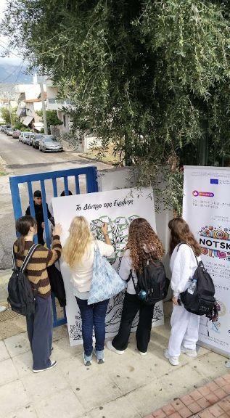
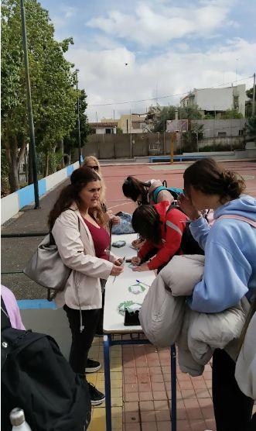

LARC 3: Round table
A round table discussion was organised by the Municipality of Fyli within the framework of the NOT SKIP – Network of Organizations and Towns for Promoting Skills for Participation project, funded under the CERV – Citizens, Equality, Rights and Values Programme. The event took place on 25 November at the Social Services Department and brought together 9 participants, including 2 local stakeholders (CSOs/education representatives), 2 representatives of local authorities, 1 expert, and 4 citizens and youth representatives.
The discussions highlighted the positive impact of the NOT SKIP project on young people in the Municipality of Fyli by increasing their knowledge of EU institutions, strengthening active citizenship skills, and encouraging democratic participation. As the first initiative of its kind in the municipality, the project introduced innovative opportunities for youth engagement in European affairs.
Participants noted that many young citizens have limited awareness of their role in shaping the Future of Europe and are largely unfamiliar with existing EU participation mechanisms. They emphasized the need for improved civic education, stronger communication, and more accessible participation tools, including online platforms, school-based activities, simulations, and public discussions, to encourage meaningful citizen engagement.
The round table also underlined the crucial role of local decision-makers as intermediaries between citizens and EU institutions. However, participants identified several barriers to effective participation, including limited local resources, weak communication, lack of transparency, the digital divide, and low levels of trust between citizens, national governments, and EU institutions. The limited follow-up to the recommendations of the Conference on the Future of Europe, particularly regarding citizen engagement, was also highlighted.
COMMUNICATION AND DISSEMINATION LINKS:
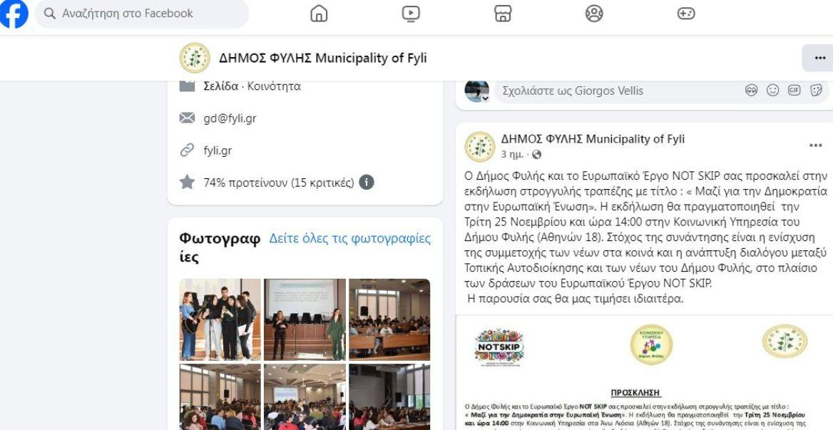

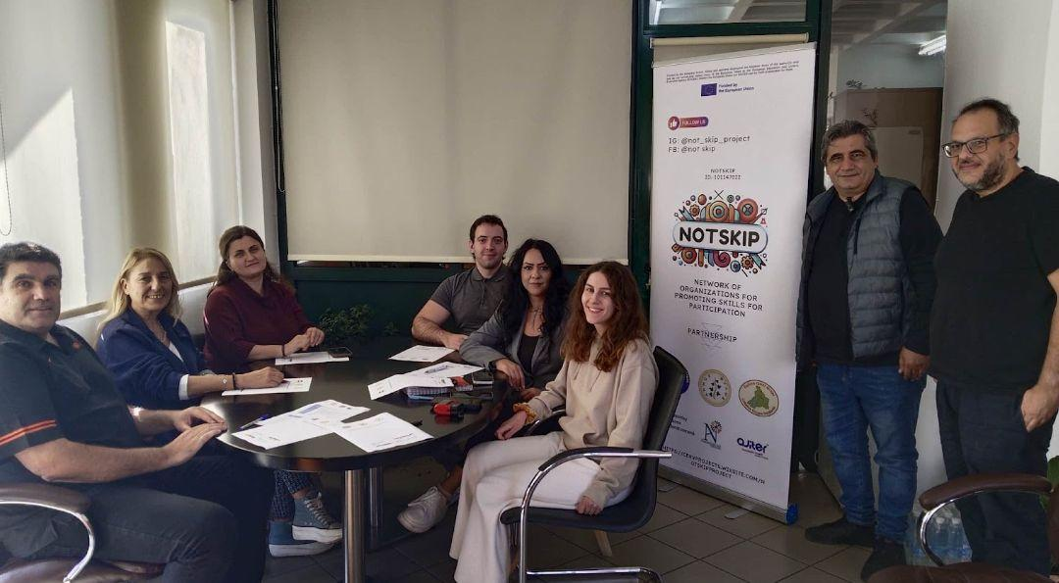

LARC 4: Focus group
The Municipality of Fyli organised two focus groups to explore how citizens, particularly young people, can become more actively involved in shaping the Future of Europe. The first focus group was held on 20 February 2026 at the Social Services of the Municipality of Fyli (Central Hall) and involved 13 participants (youth workers, educators, trainers, teachers and facilitators who had participated in previous NOT SKIP international meetings). The second focus group took place on 12 March 2026 at the Lyceum of Fyli (Department of Hasia) with 16 young participants (12 aged 18+ and 4 under the age of 18). Overall, 29 participants took part in the two focus groups.
The discussions highlighted the importance of strengthening civic participation through closer cooperation between educational institutions, municipalities, youth organisations and local communities. Participants agreed that schools and local authorities play a crucial role in promoting democratic values and creating opportunities for young people to engage in decision-making processes. Particular emphasis was placed on experiential learning methods, such as simulations of EU decision-making processes, youth forums, consultation meetings, community co-creation activities, and local events celebrating European citizenship. These initiatives were considered effective ways to increase young people's understanding of democratic processes and encourage active participation.
The focus groups concluded that increasing youth participation requires greater transparency, accessible information about European participation opportunities, and stronger links between young people and decision-makers at both local and European levels. Participants recommended expanding civic education activities in schools, strengthening youth councils and consultation mechanisms, promoting interactive learning tools, and organising regular dialogues between local authorities, Members of the European Parliament, civil society organisations, and young citizens. Overall, the discussions confirmed that empowering young people through education, participation, and cooperation is essential for building a more inclusive, democratic, and resilient Europe, fully aligned with the objectives of the NOT SKIP project.

COMMUNICATION AND DISSEMINATION LINKS:
https://www.facebook.com/SocialServicesFyli/posts/pfbid024CWoZufPc5r4qTto6VineNQjyAknLNoK1oUmQ8BvxgT9LiFkoSgswp6eNsiRhUrRl
(Post on the official Facebook page of the Social services of Municipality of Fyli)

PHOTOS:
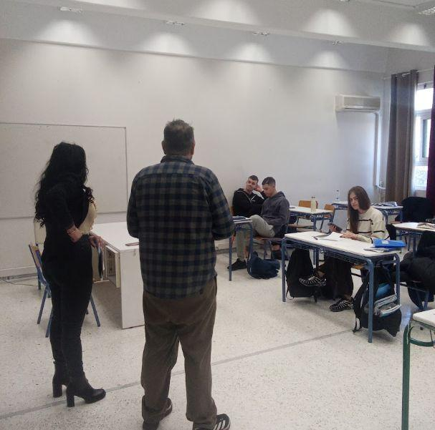
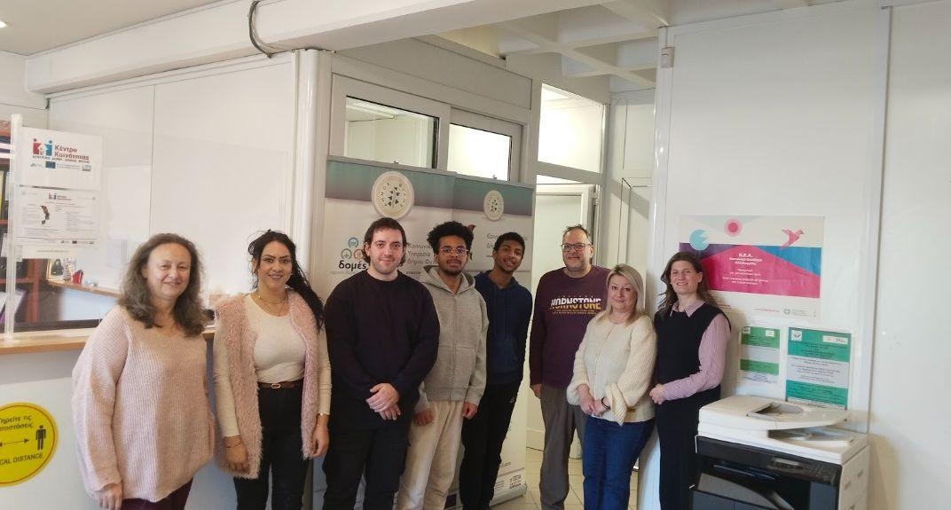

LARC 5: Podcast
The Municipality of Fyli hosted a podcast interview with Member of the Hellenic Parliament Vangelis Liakos, representing the West Attica constituency. The discussion focused on the importance of active citizenship, democratic participation, and the role of citizens in shaping both their local communities and the future of Europe.
During the interview, Mr. Liakos highlighted the importance of encouraging young people to participate in democratic processes and emphasized the value of European programmes in promoting civic engagement, social cohesion, and active citizenship. He also underlined the key role of local authorities as a bridge between citizens and national and European institutions, helping to strengthen trust, dialogue, and public participation in decision-making.
The podcast was moderated by Konstantina Koutsouna, Social Worker at the Community Centres of the Municipality of Fyli, and formed part of the project's dissemination activities. By featuring the youngest Member of the Hellenic Parliament, elected in the West Attica region, the podcast provided valuable insights into participatory democracy from the perspective of a representative closely connected to the local community. The interview contributed to raising public awareness of the objectives of the NOT SKIP project and promoted dialogue on strengthening citizens' participation in democratic life across Europe.

COMMUNICATION AND DISSEMINATION LINKS:
https://fyli.gr/i-synenteyxi-toy-voyleyti-vaggeli-liakoy-sto-plaisio-toy-programmatos-not-skip-toy-dimoy-fylis/
https://www.youtube.com/watch?v=PjhBWbz7hQY&t=8s

PHOTOS:
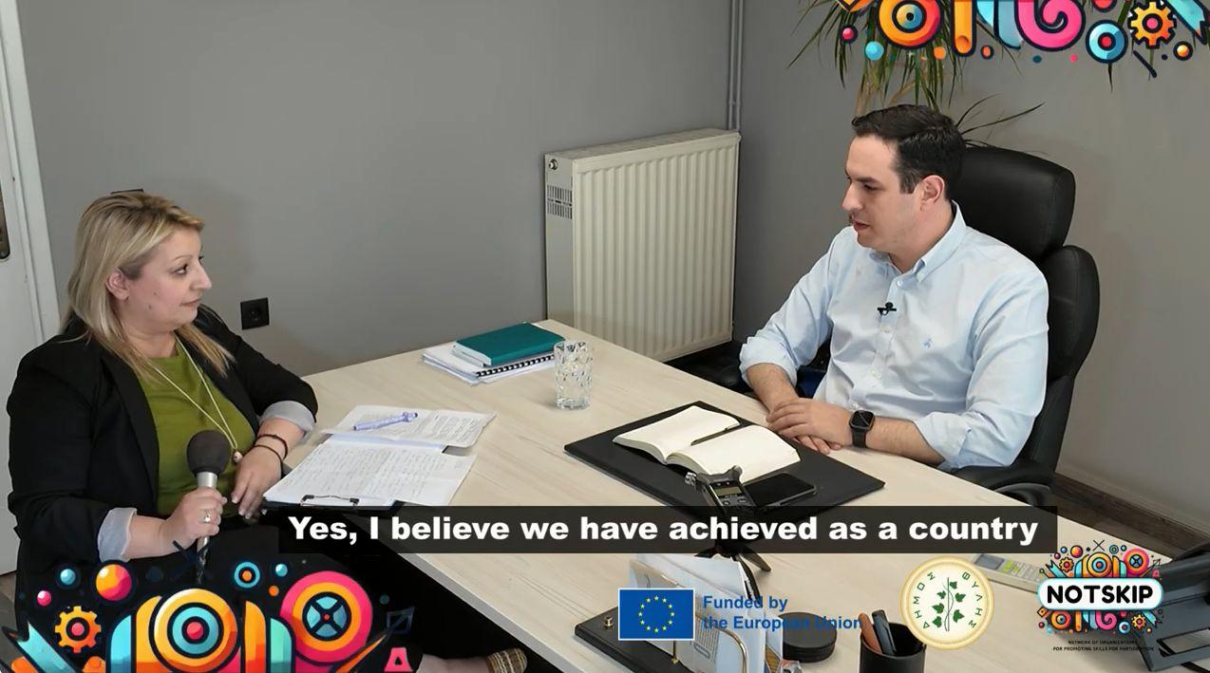

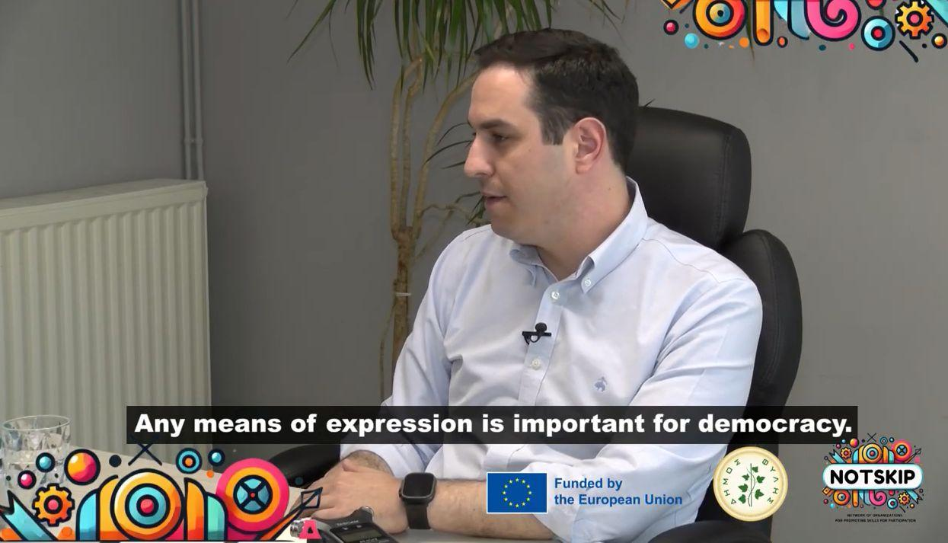

LARC 6: Dissemination event
The Municipality of Fyli organized a series of three Local Awareness Raising and Dissemination Events as part of the NOT SKIP – Network of Organizations and Towns for Promoting Skills for Participation project under the CERV Programme. The events were held on 9 June 2026 at the Municipal Hall, 12 June 2026 at the Cultural Association of Fyli, and 15 June 2026 at the Social Services of the Municipality of Fyli. A total of 75 participants attended the three events, including local and regional decision-makers, elected representatives, civil society organisations, active citizens, municipal employees, social service professionals, educators, and youth workers.
Each event addressed the interests of a different target group. Discussions with local decision-makers focused on integrating the project's recommendations into local governance and participatory processes. Citizens explored ways to become more actively involved in community life and democratic decision-making, while professionals working in education, youth, and social services examined how the project's methodologies could be applied to strengthen civic competences and cooperation between schools, social services, and local authorities.
Overall, the dissemination campaign successfully increased awareness of the NOT SKIP project and its outcomes. Participants welcomed the practical tools and recommendations developed by the project and emphasized the importance of stronger cooperation between public authorities, educational institutions, civil society, and citizens. At the same time, discussions highlighted the need to further improve local awareness and ensure that socially vulnerable groups, including the Roma community, are more effectively included in democratic participation processes. The events contributed to reinforcing the project's long-term objective of promoting inclusive governance and active citizenship within the Municipality of Fyli.

COMMUNICATION AND DISSEMINATION LINKS:
https://www.facebook.com/share/p/1EE7ouVtYs/

PHOTOS:

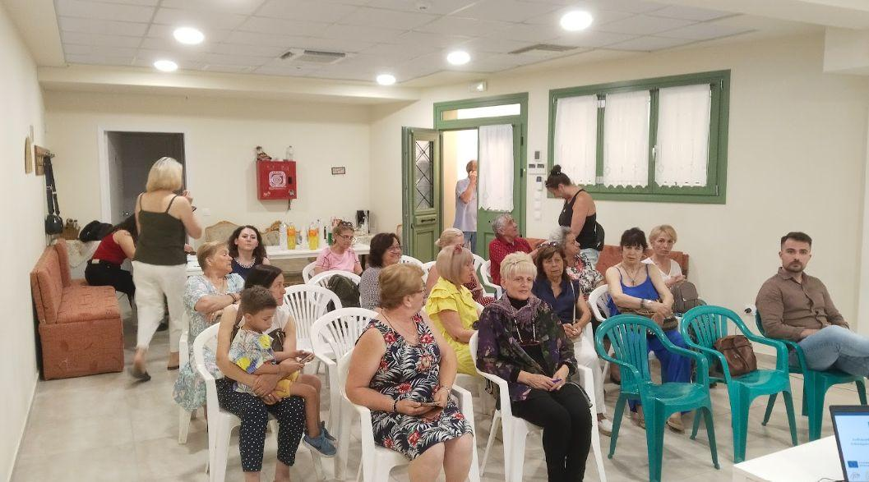

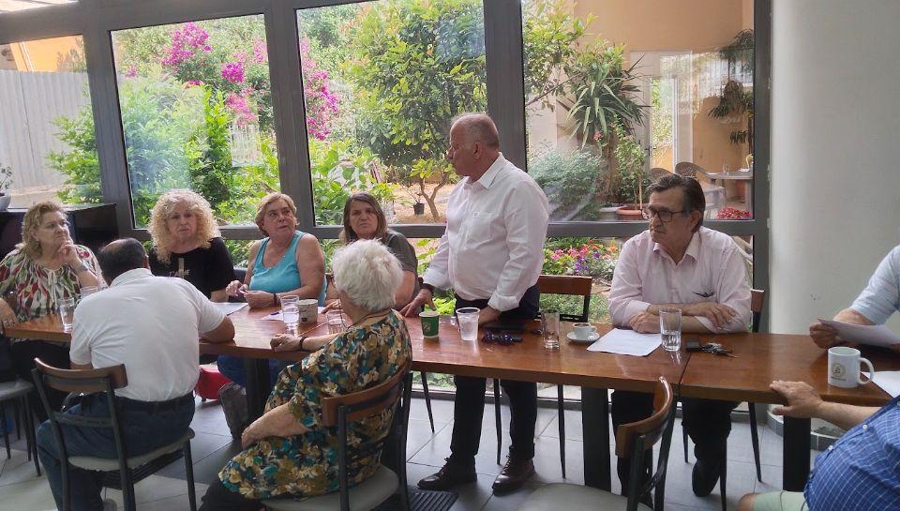

HISTORY OF CHANGES
VERSION | PUBLICATION DATE | CHANGE
1.0 | 01.04.2022 | Initial version (new MFF).

