EVENT DESCRIPTION SHEET
(To be filled in and uploaded as deliverable in the Portal Grant Management System, at the due date foreseen in the system.
Please provide one sheet per event (one event = one workpackage = one lump sum).)
PROJECT
Participant: | [1] - [Fattoria Pugliese Diffusa APS] (FPD])
PIC number: | [945384311 ]
Project name and acronym: | [Network of organizations for Promoting Skills for Participation] — [acronym]

EVENT DESCRIPTION
Event number: | [Work Package 6]
Event name: | [Local Awareness Raising Campaigns in Italy (LARC)]]
Type: | [desk research, street debate, round table, focus groups, podcast, local dissemination]
In situ/online: | [in-situ]
Location: | [Italy], [Taurisano]
Date(s): | [Desk research: 4 May 2025;  Street debate: 26 November 2025;  Round table:17 and 18 November  Focus groups: 9 February and 19 February 2026  Podcast: 21 April 2026  Dissemination event: 26 June 2026]
Website(s) (if any):
Participants
Female: | 77
Male: | 56
Non-binary: | 0
From country 1 [Italy]: | 133
Total number of participants: | 133 | From total number of countries: | 1
Description
Provide a short description of the event and its activities.
LARC 1: Desk Research
The desk research focused on identifying and collecting national and European good practices that use cultural activities to promote democracy, volunteering, and active citizenship. The project team analysed initiatives addressing topics such as social inclusion, gender equality, environmental awareness, and community participation through artistic and cultural approaches. The selected good practices were shared through the project's communication channels to inspire citizens and stakeholders, while providing valuable input for the development of the NOTSKIP recommendations and the implementation of the following project activities.
COMMUNICATION AND DISSEMINATION LINKS:
https://www.instagram.com/p/DJUI_MKMMvd/
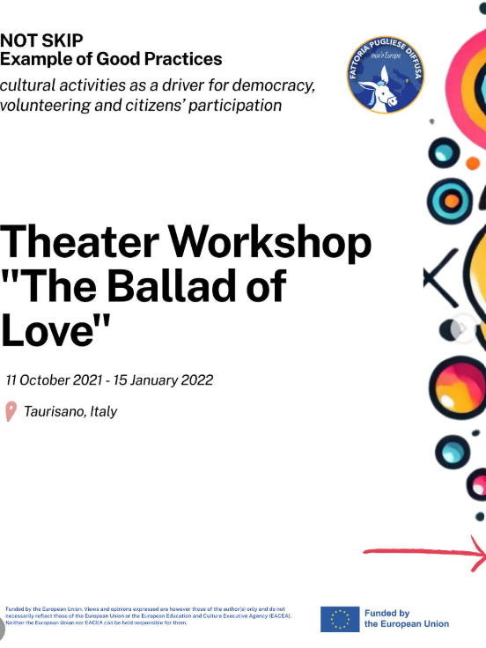
LARC 2: Street debate
On 26 November 2025, Fattoria Pugliese Diffusa APS organized a Street Debate in Taurisano, Italy, as part of the NOTSKIP project. The activity invited local citizens to take part in an informal public consultation on the question "How can we live together in peace?". A total of 60 participants engaged in conversations with the project facilitators, sharing personal reflections and practical ideas on how to promote peaceful coexistence in everyday life. More than 40 contributions were collected, highlighting the importance of mutual respect, empathy, active listening, education, solidarity, and openness towards others. The activity strengthened dialogue within the local community, encouraged citizens to reflect on their role in creating an inclusive society, and provided qualitative input for the development of the NOTSKIP recommendations on democratic participation and social cohesion.

COMMUNICATION AND DISSEMINATION LINKS:

https://www.instagram.com/p/DSNMlz-jEby/?igsh=MWt2emo2NGg5Nno1cA%3D%3D
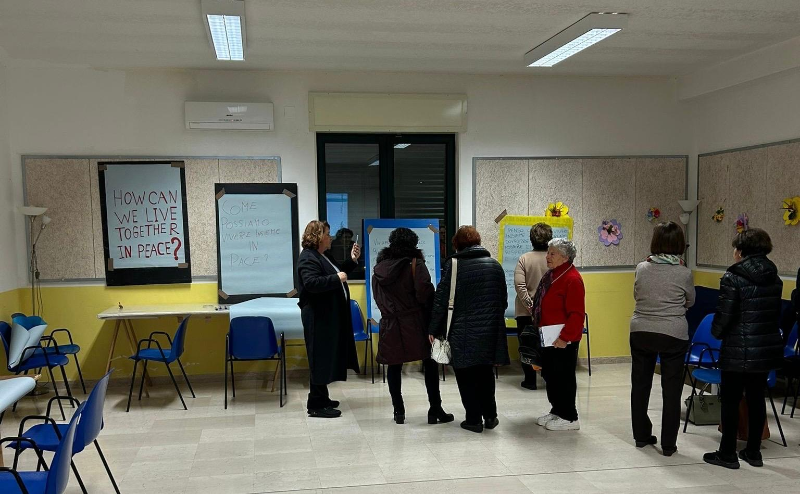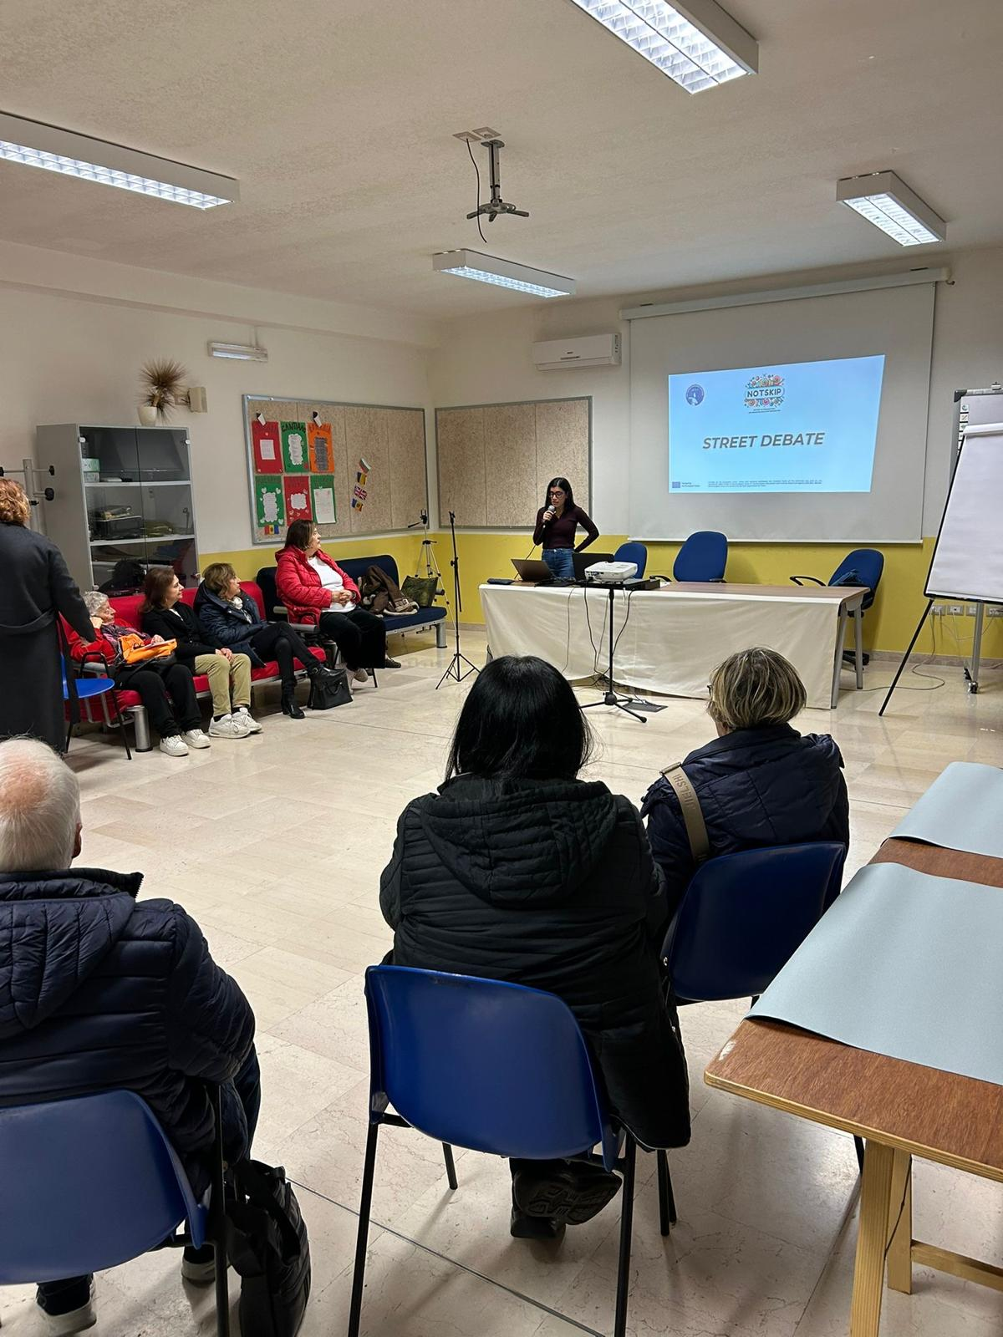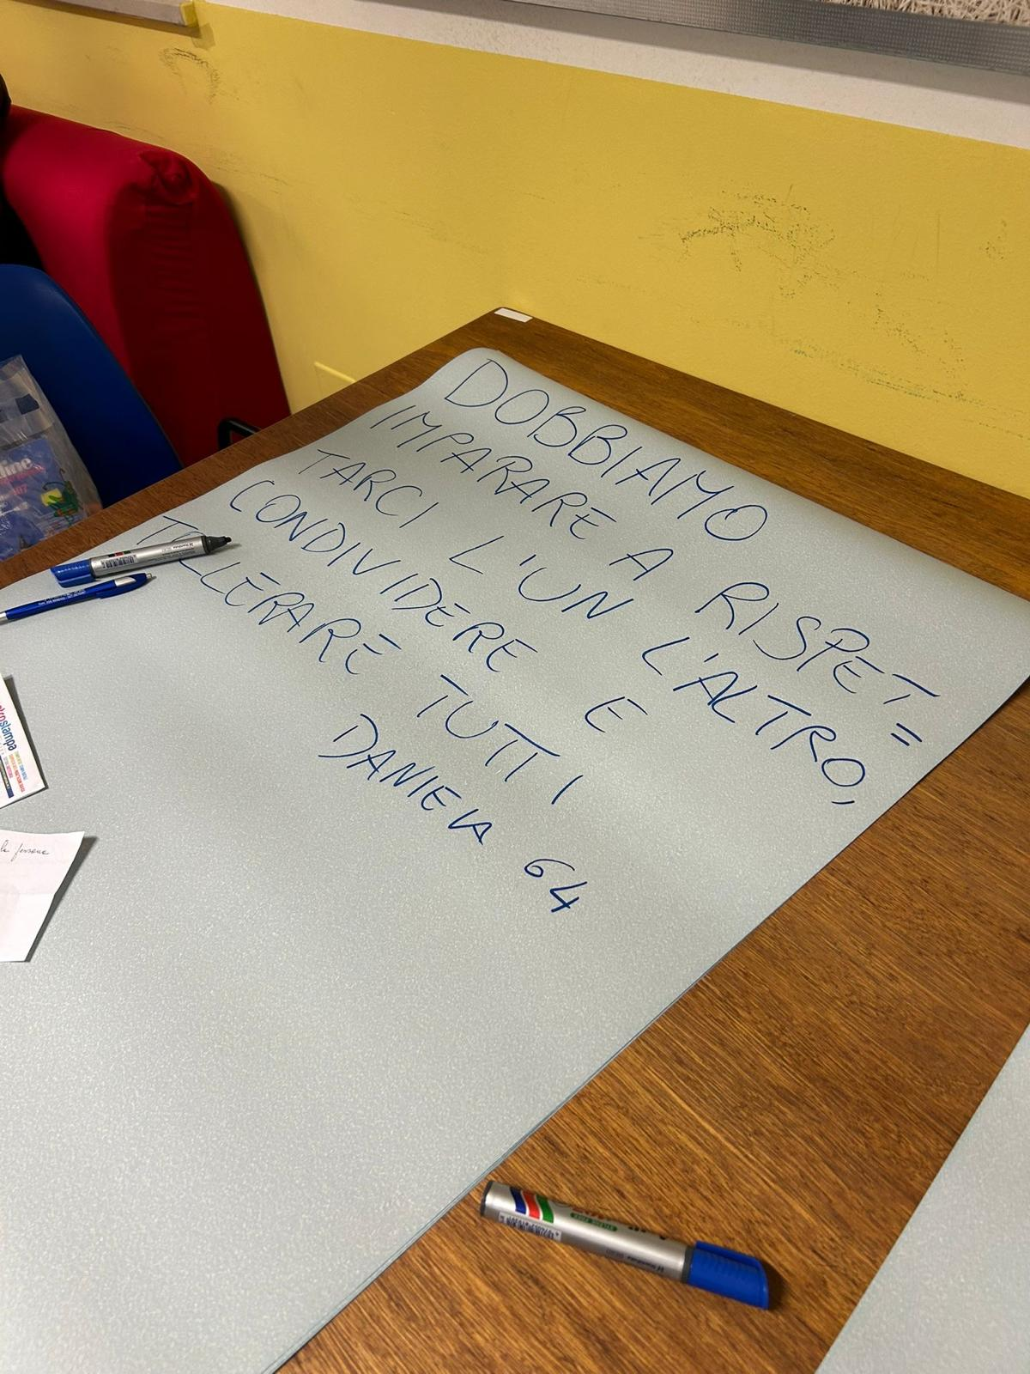

LARC 3: Round table
The round table was organized on 17-18 November 2025 in Ruffano, Italy, bringing together 12 participants, including local stakeholders, local authorities, experts, citizens, and youth representatives. The event focused on strengthening democratic participation and exploring ways to increase citizens’ involvement in local and European decision-making processes. Through interactive discussions, participants identified key challenges related to trust in institutions, access to information, digital inclusion, awareness of EU participation tools, and the involvement of less active groups. The discussion highlighted the importance of accessible participation mechanisms, stronger communication between citizens and institutions, the role of local authorities as mediators, and the creation of inclusive spaces for dialogue. The activity contributed to the development of recommendations aimed at promoting active citizenship, transparent participation, and stronger community engagement.
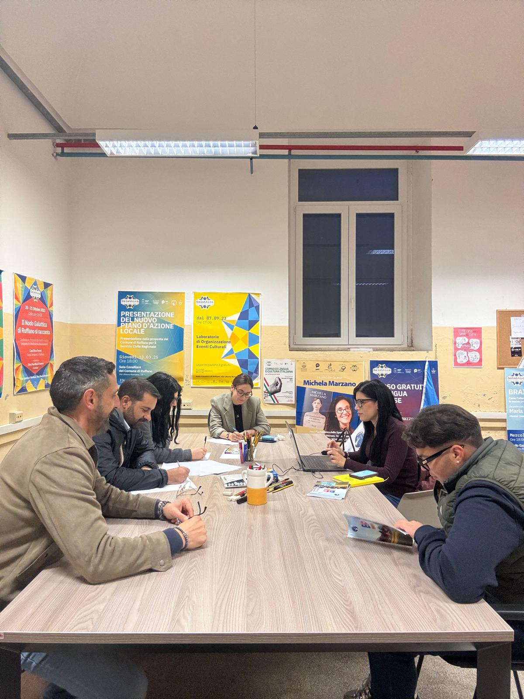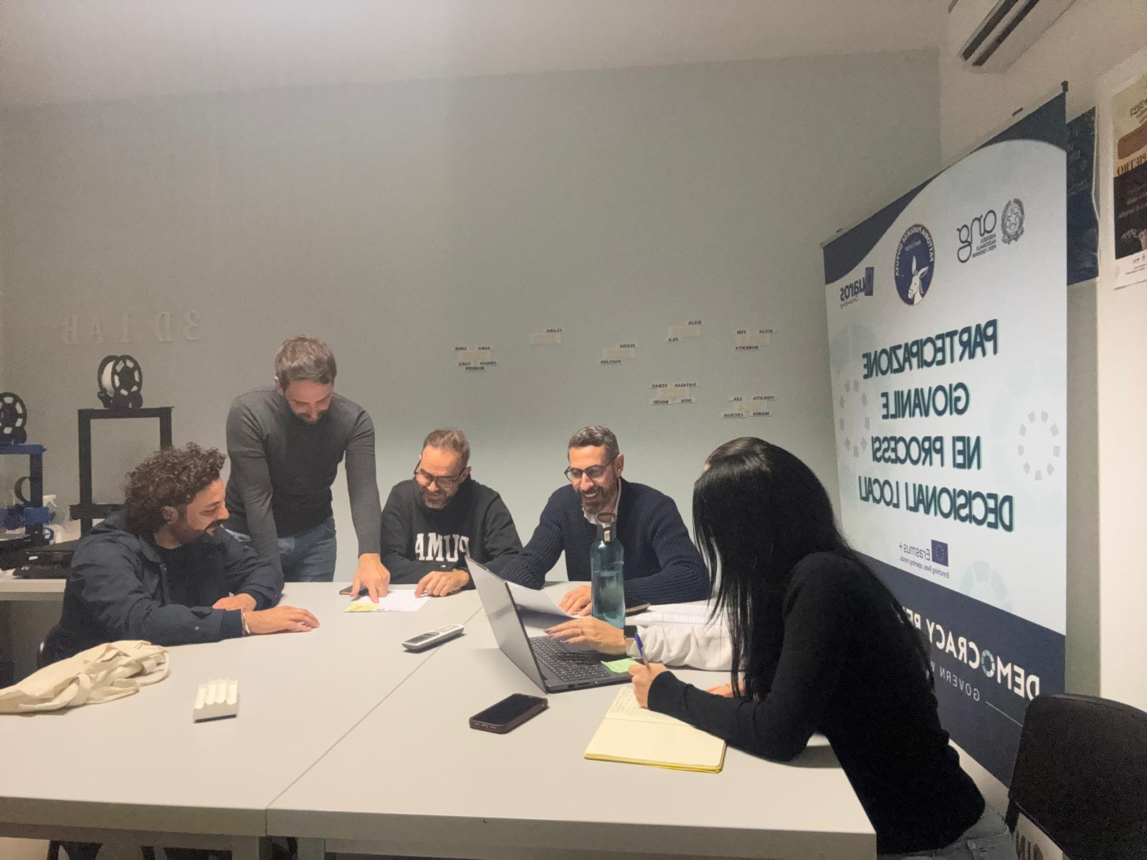

LARC 4: Focus group
The focus group activities were implemented with two different target groups in order to collect perspectives on civic participation, youth engagement, and the role of education in strengthening democratic involvement.
FOCUS GROUP 1: Youth workers, educators, trainers and teachers
The focus group was organized on 9 February 2026 in Taurisano, Italy, involving 10 professionals working with young people. The activity explored grassroots initiatives to promote citizens’ engagement in shaping the Future of Europe and the role of education in fostering active citizenship. Participants discussed barriers affecting youth participation, such as lack of awareness, limited communication, territorial barriers, and the perception of European processes as distant. The discussion highlighted the importance of experiential civic education, cooperation between schools and local organizations, inclusive participation spaces, and the development of educators’ skills in communication, active listening, and participatory methodologies. The results contributed to the development of NOTSKIP recommendations and the promotion of democratic participation.
FOCUS GROUP 2: Young people
The second focus group was organized on 19 February 2026 in Casarano, Italy, involving 27 young people. The activity explored young people’s perceptions of the Future of Europe, civic participation, EU participatory tools, and the barriers limiting youth engagement. Participants discussed key issues affecting their generation, including climate change, education, employment opportunities, and social inclusion. The discussion highlighted the need for more accessible institutional communication, stronger youth involvement in decision-making processes, and more opportunities for participation through workshops, volunteering, youth forums, and digital platforms. The outcomes contributed to the development of NOTSKIP recommendations and the promotion of active citizenship at local and European level.
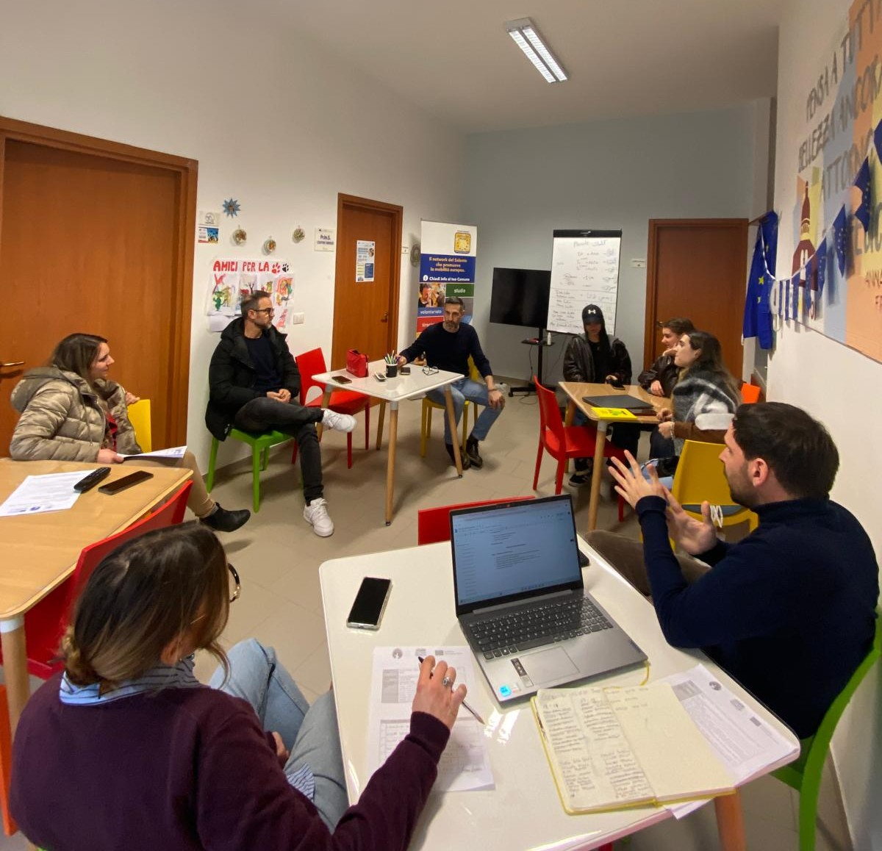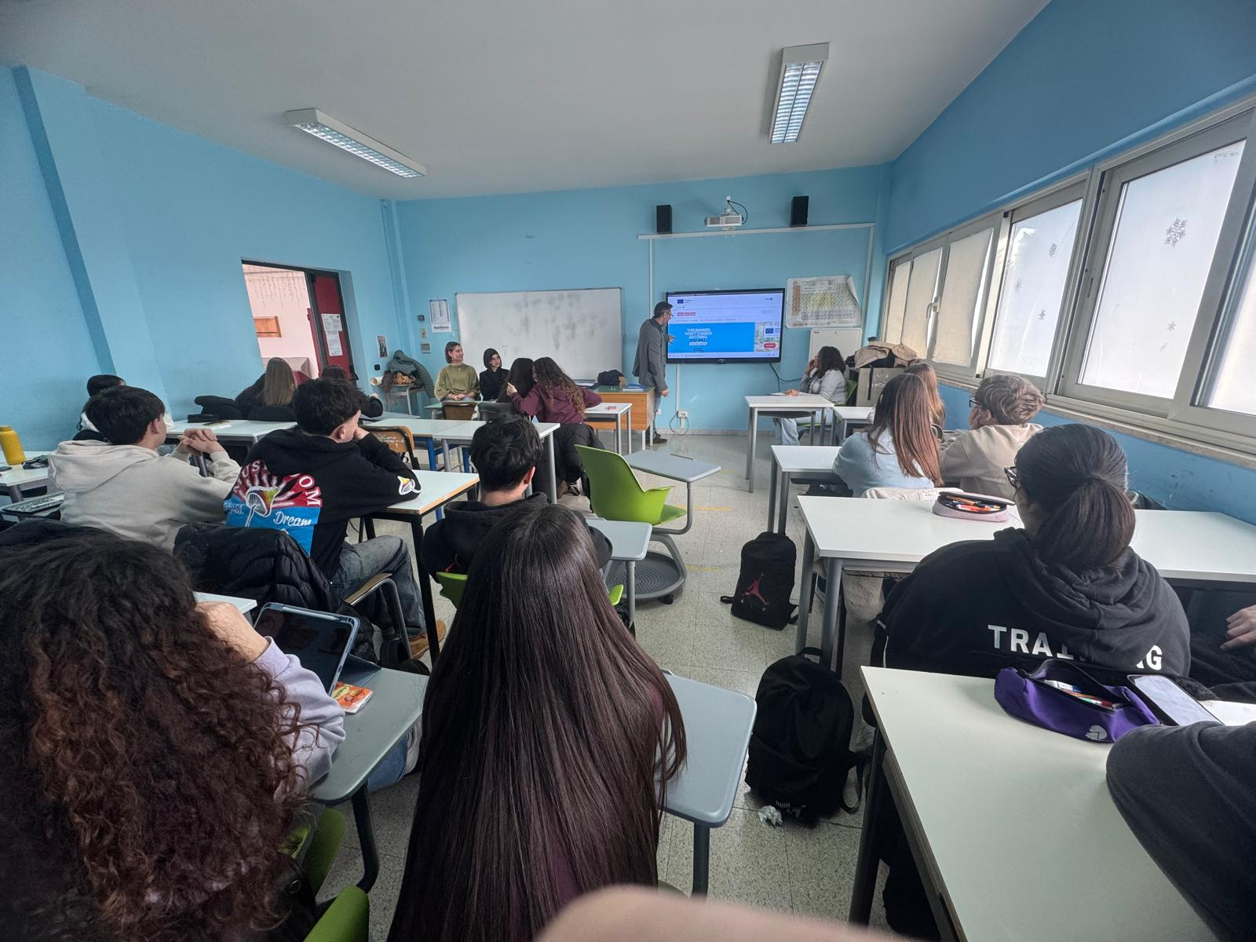

LARC 5: Podcast
Within the communication activities of the NOTSKIP project, Fattoria Pugliese Diffusa APS created a podcast episode entitled “The Voice of the Territory: Italy Between Participation and Reality” together with Fatto Radio, featuring Federico Gaviano from TDM2000. The episode explored how citizens can transform their ideas and concerns into concrete actions through participatory democracy. The discussion addressed important challenges such as the digital divide, the relationship between citizens and institutions, and the need to strengthen democratic engagement at local level. By sharing experiences from different territories, the podcast contributed to spreading NOTSKIP recommendations and encouraging reflection on active citizenship, inclusion, and new forms of participation in the Future of Europe.
LARC 6: Dissemination event
On 26 June 2026, Fattoria Pugliese Diffusa APS organized the local dissemination event of the NOTSKIP project in Taurisano, Italy, involving 23 participants, including citizens, stakeholders, civil society organizations, schools, and community representatives. The event aimed to present the project’s results, achievements, and good practices, while promoting dialogue and networking among local actors. Participants discussed the importance of active citizenship, democratic participation, and the sustainability of project outcomes, contributing to the wider dissemination and future exploitation of NOTSKIP results at local level.
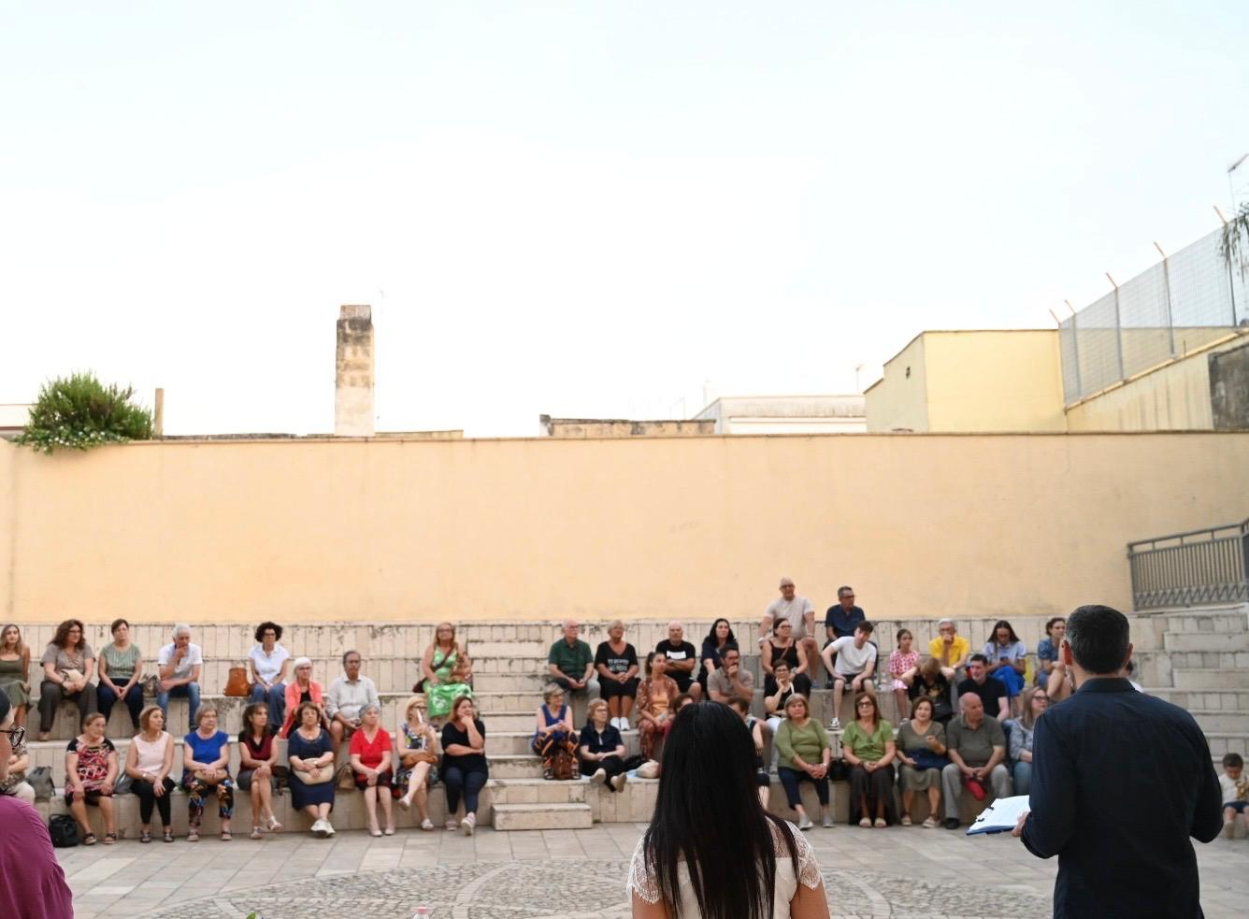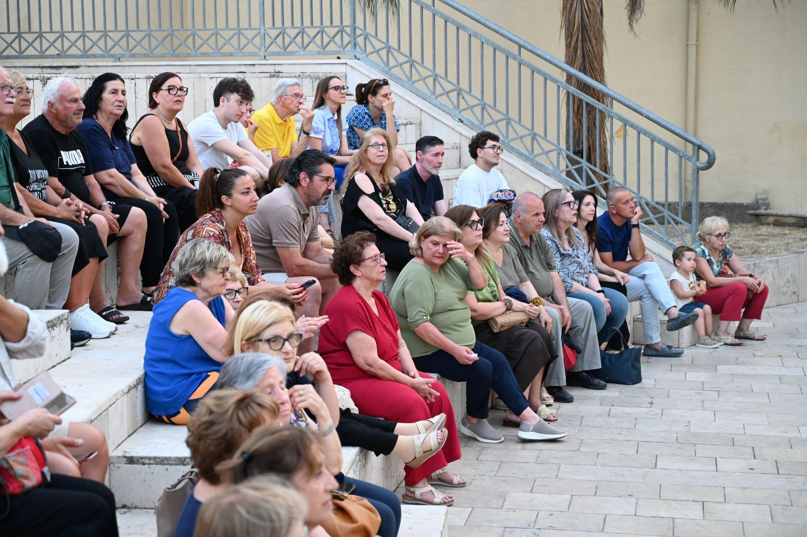

HISTORY OF CHANGES
VERSION | PUBLICATION DATE | CHANGE
1.0 | 01.04.2022 | Initial version (new MFF).

