EVENT DESCRIPTION SHEET
(To be filled in and uploaded as deliverable in the Portal Grant Management System, at the due date foreseen in the system.
Please provide one sheet per event (one event = one workpackage = one lump sum).)
PROJECT
Participant: | [1] - [Asociatia Nameless Art] ([ANA])
PIC number: | [912797258]
Project name and acronym: | [Network of organizations for Promoting Skills for Participation] — [acronym]

EVENT DESCRIPTION
Event number: | [Work Package 8]
Event name: | [Local Awareness Raising Campaigns in Romania (LARC)]
Type: | [desk research, street debate, round table, focus group, podcast, dissemination event]
In situ/online: | [in-situ]
Location: | [Romania], [Baicoi, Ploiesti, Plopeni, Brasov]
Date(s): | [Desk research: 13 February 2025;  Street debate: 18 October 2025;  Round table:22 November 2025  Focus groups: 12, 19 and 22 February 2026  Podcast: 28 March 2026  Dissemination event: 05 June 2026 ]
Website(s) (if any): | IG: https://www.instagram.com/asociatia_nameless_art  FB: https://www.facebook.com/share/1B1Vg5tCE4/?mibextid=wwXIfr  WEBSITE: https://assnamelessart.wixsite.com/namelessart
Participants
Female: | 70
Male: | 64
Non-binary: | 0
From country 1 [Romania]: | 134
Total number of participants: | 134 | From total number of countries: | 1
Description
Provide a short description of the event and its activities.
LARC 1: Desk research
The future NOTSKIP facilitator together with the national project coordination have done a desk research looking for cultural activities good practices as a driver for democracy, volunteering and citizens’ participation. The analyses resulted in several national good practices that successfully use culture, education, and community engagement to strengthen democratic participation and active citizenship.
The research highlighted initiatives such as One World Romania, Funky Citizens, and Femei pe Mătăsari, which demonstrate how cultural events, civic education campaigns, public debates, and community-led activities can encourage citizens to become more informed, engaged, and active in democratic processes. The collection of these good practices provided valuable inspiration for the development of the NOTSKIP recommendations and offered transferable models that can support citizen participation, social inclusion, and civic engagement at both local and European levels.
COMMUNICATION AND DISSEMINATION LINKS:
https://www.instagram.com/p/DJOPVuysvbE/?igsh=cHgyMWpmY28yYzI4
https://www.instagram.com/p/DJOPVuysvbE/?igsh=cHgyMWpmY28yYzI4

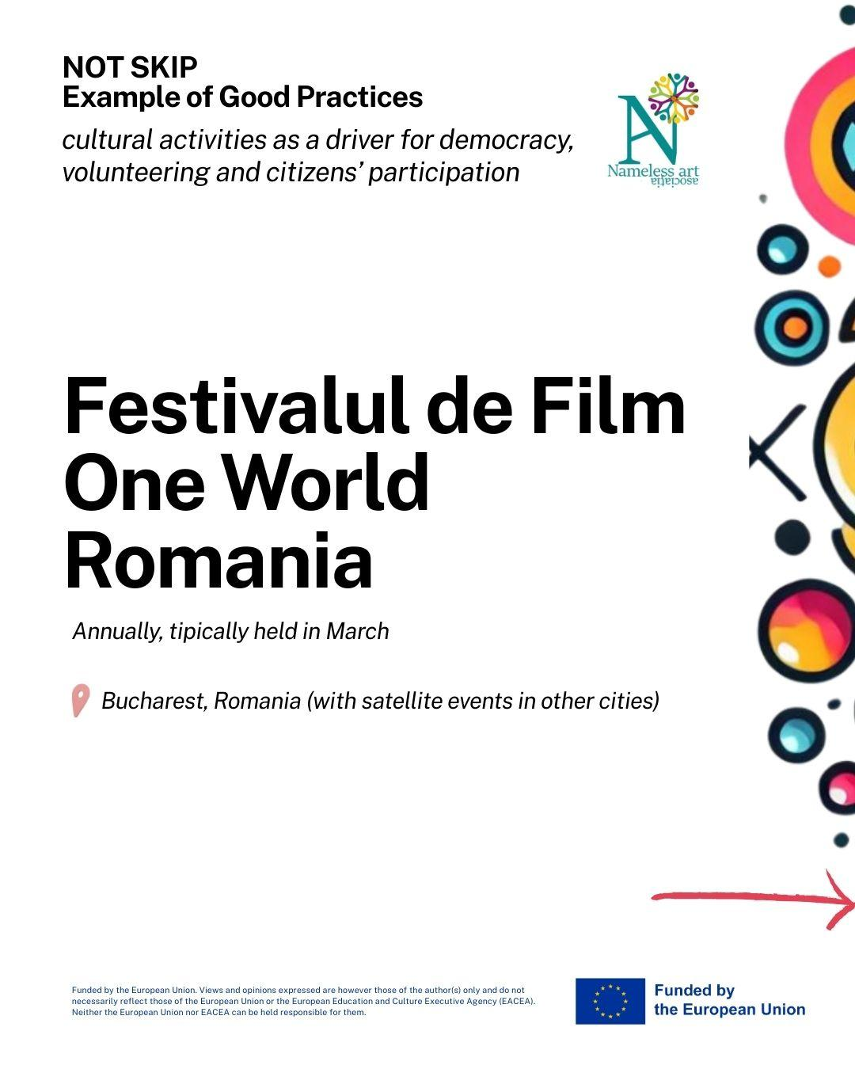

LARC 2: Street debate
On 18 October 2025, ANA organized a Street Debate in Ploiești, Romania, as part of the NOTSKIP project. The activity engaged 60 citizens of different ages and backgrounds, inviting passers-by to reflect on the question: “How can we live together in peace?”. Through open discussions and written contributions, participants shared over 40 opinions highlighting the importance of respect, empathy, communication, diversity, and cooperation. The event provided a valuable platform for citizens to express their views on peaceful coexistence, active citizenship, and the future of Europe, while fostering community dialogue and civic engagement
https://www.instagram.com/p/DP9b5hJiFc-/?igsh=czdleGh2d3JlNWRs
https://www.facebook.com/share/p/18oV8BgRNE/?mibextid=wwXIfr
https://www.facebook.com/share/p/1GVzzxqQnm/?mibextid=wwXIfr
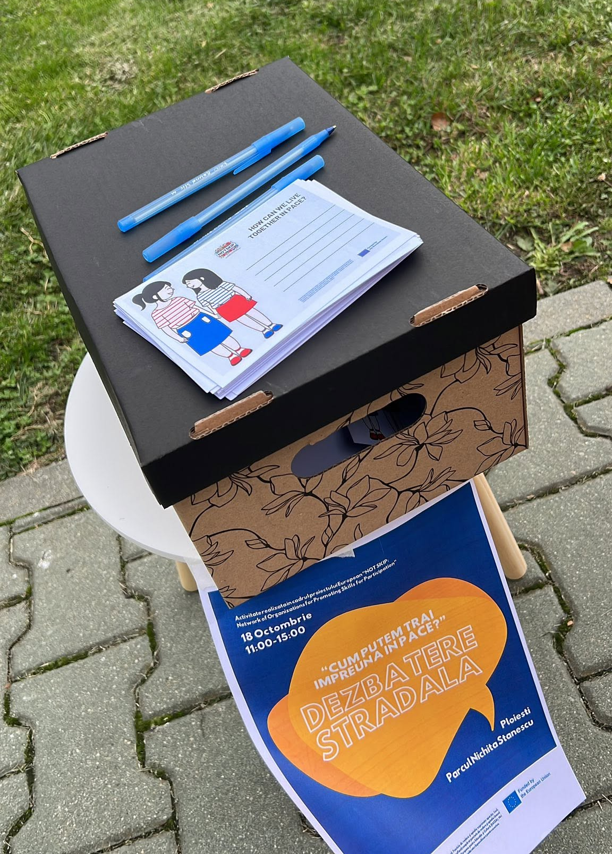
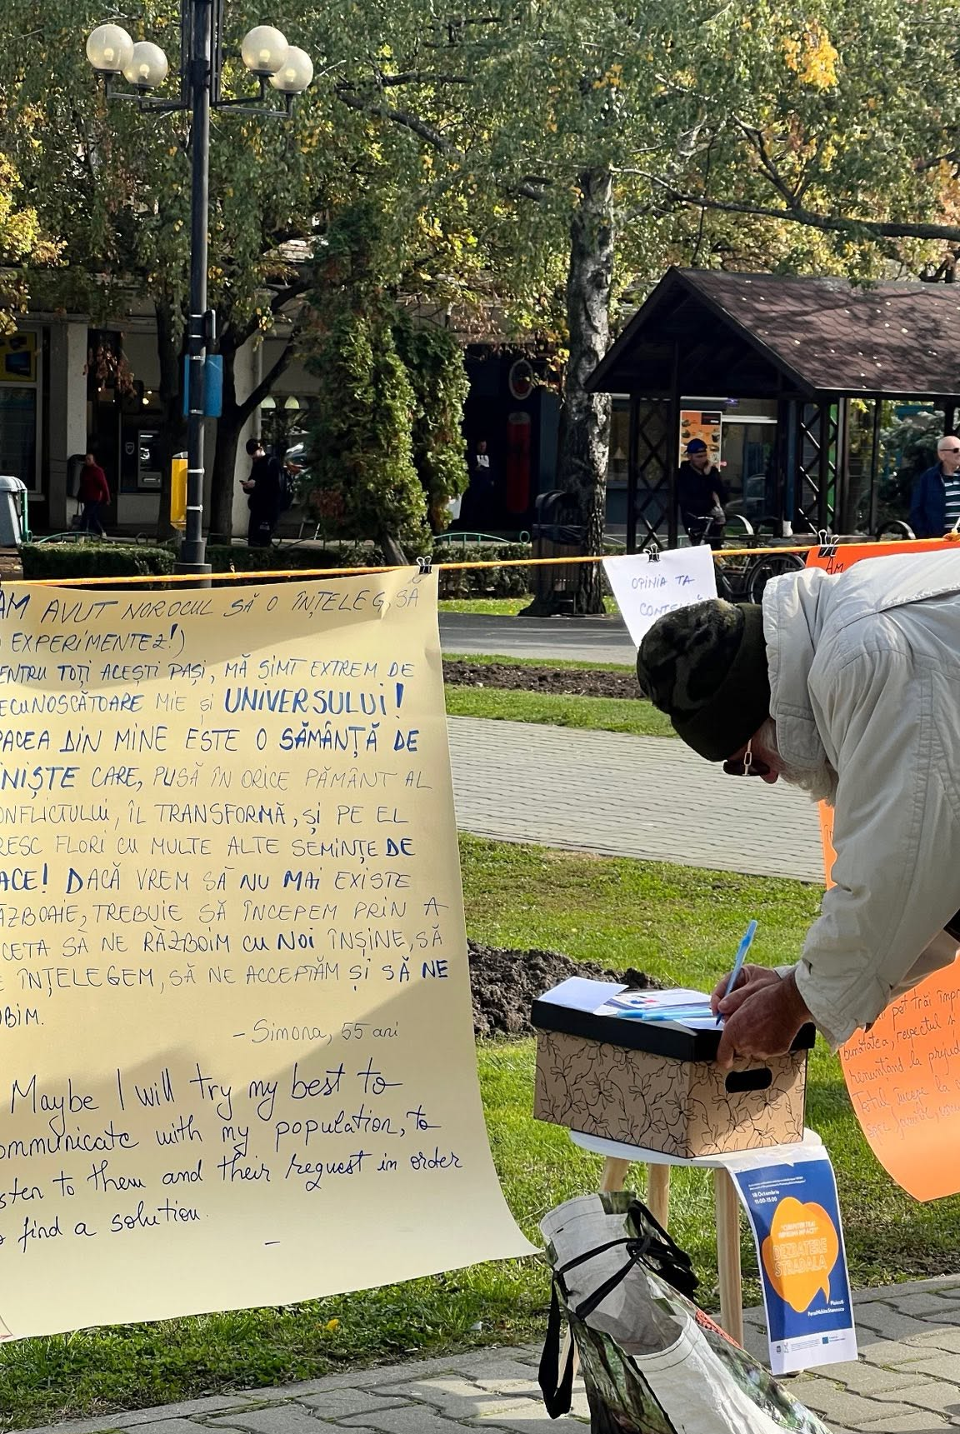
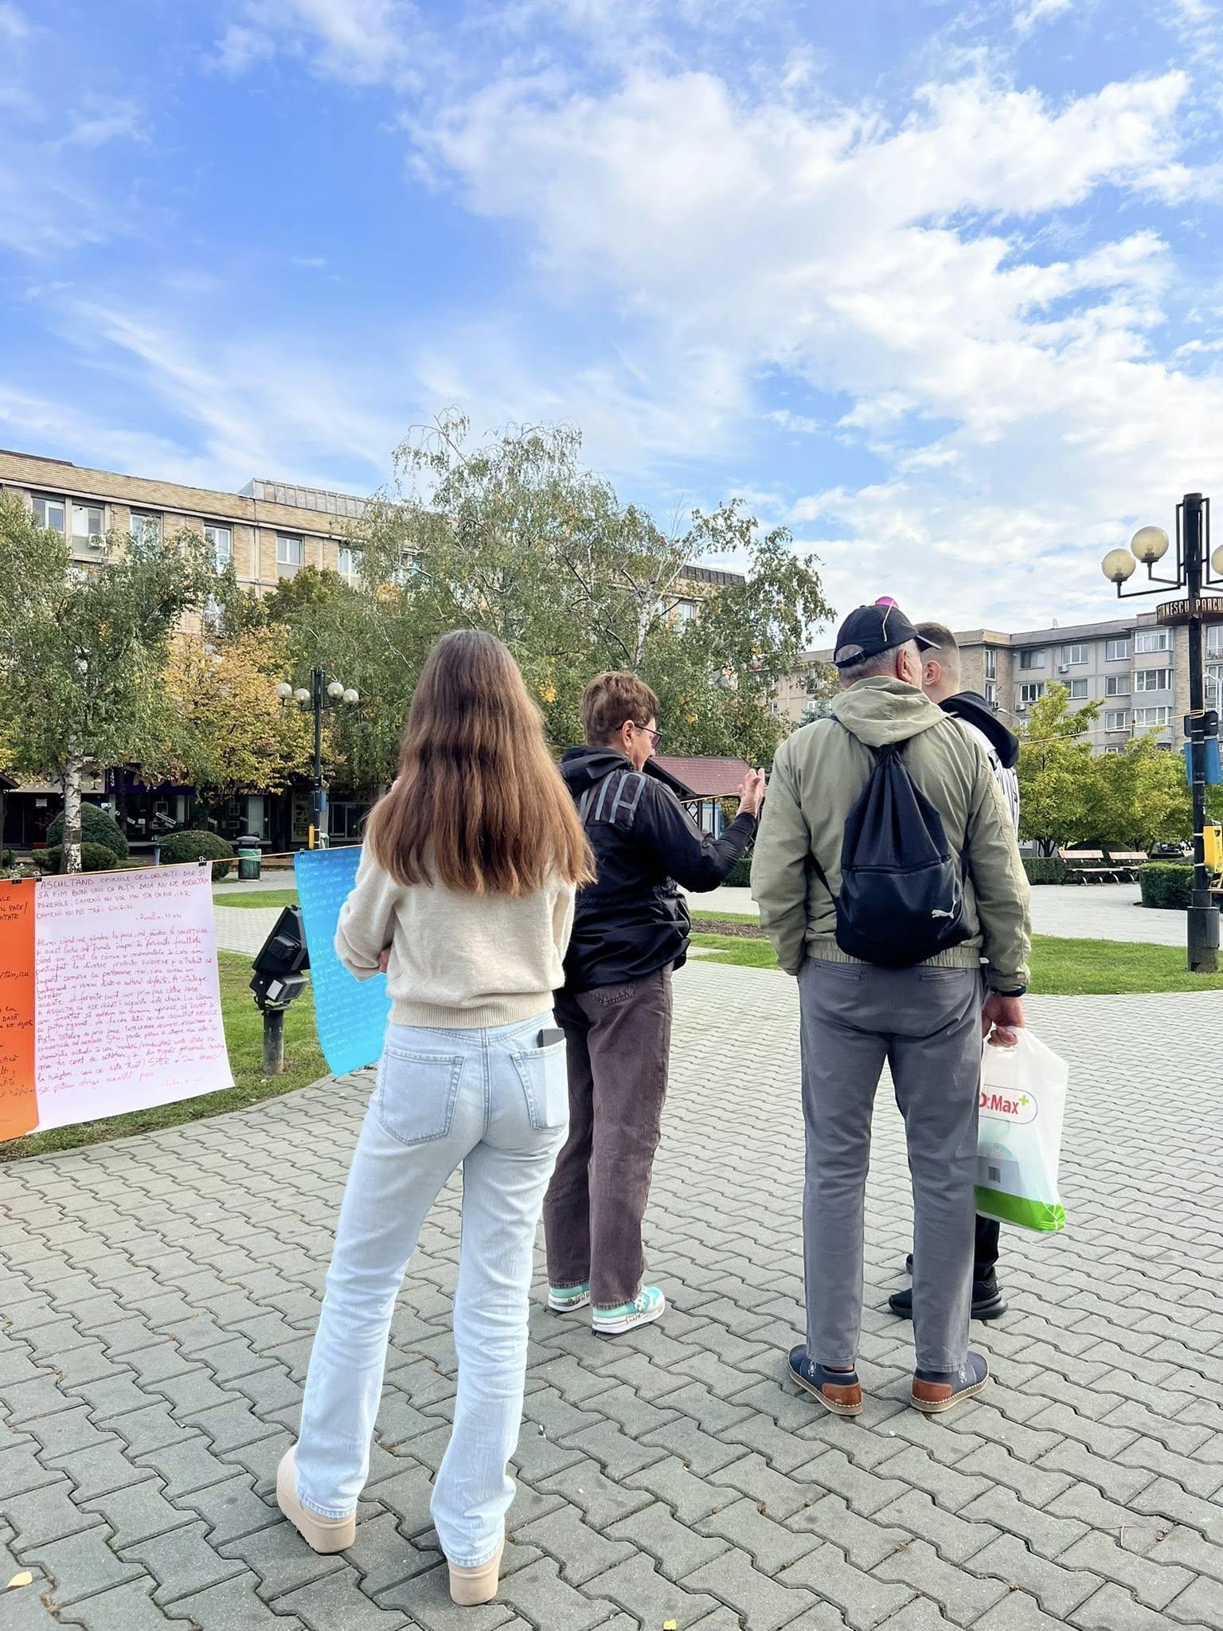

LARC 3: Round table
The round table was organized on the 22 November 2025, in Plopeni, Romania, bringing together 13 participants, including citizens, youth representatives, local stakeholders, public authorities, and experts. The event focused on strengthening democratic competences and exploring ways to increase citizens’ participation in local and European decision-making. Through interactive discussions, participants identified key challenges related to transparency, access to information, civic engagement, and trust in institutions, while proposing practical solutions such as local debates, neutral information platforms, volunteering initiatives, and community-based projects. The activity contributed to the development of recommendations aimed at promoting active citizenship, informed participation, and stronger community involvement.
COMMUNICATION AND DISSEMINATION LINKS:
https://www.facebook.com/photo?fbid=1220985240138290&set=pcb.1220985840138230
https://www.instagram.com/p/DRaFUCSCAsJ/?img_index=1
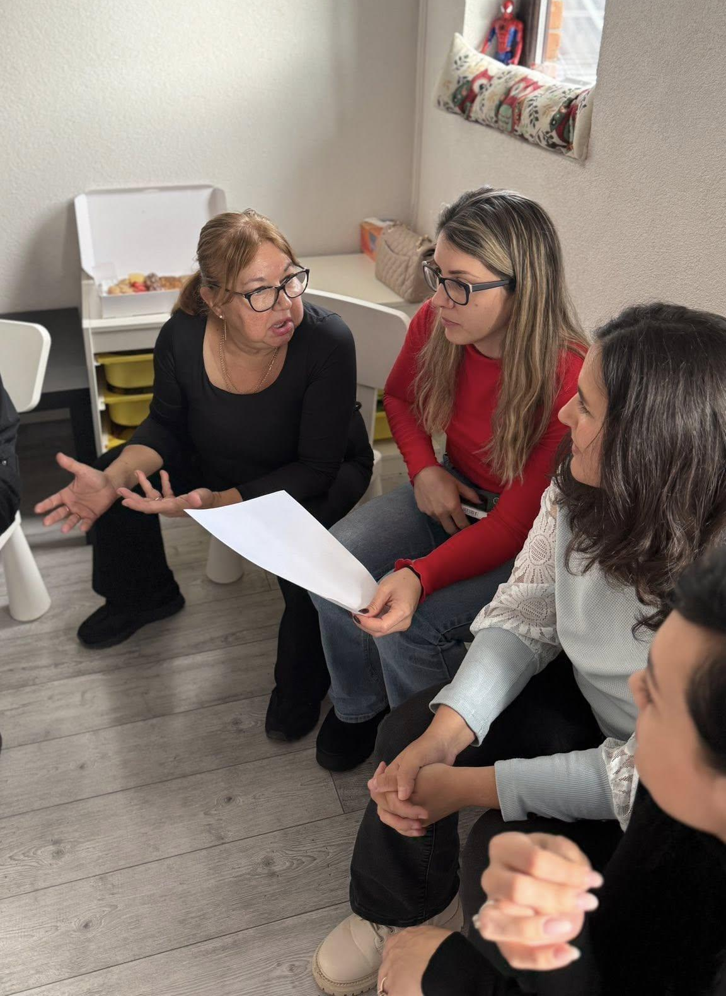
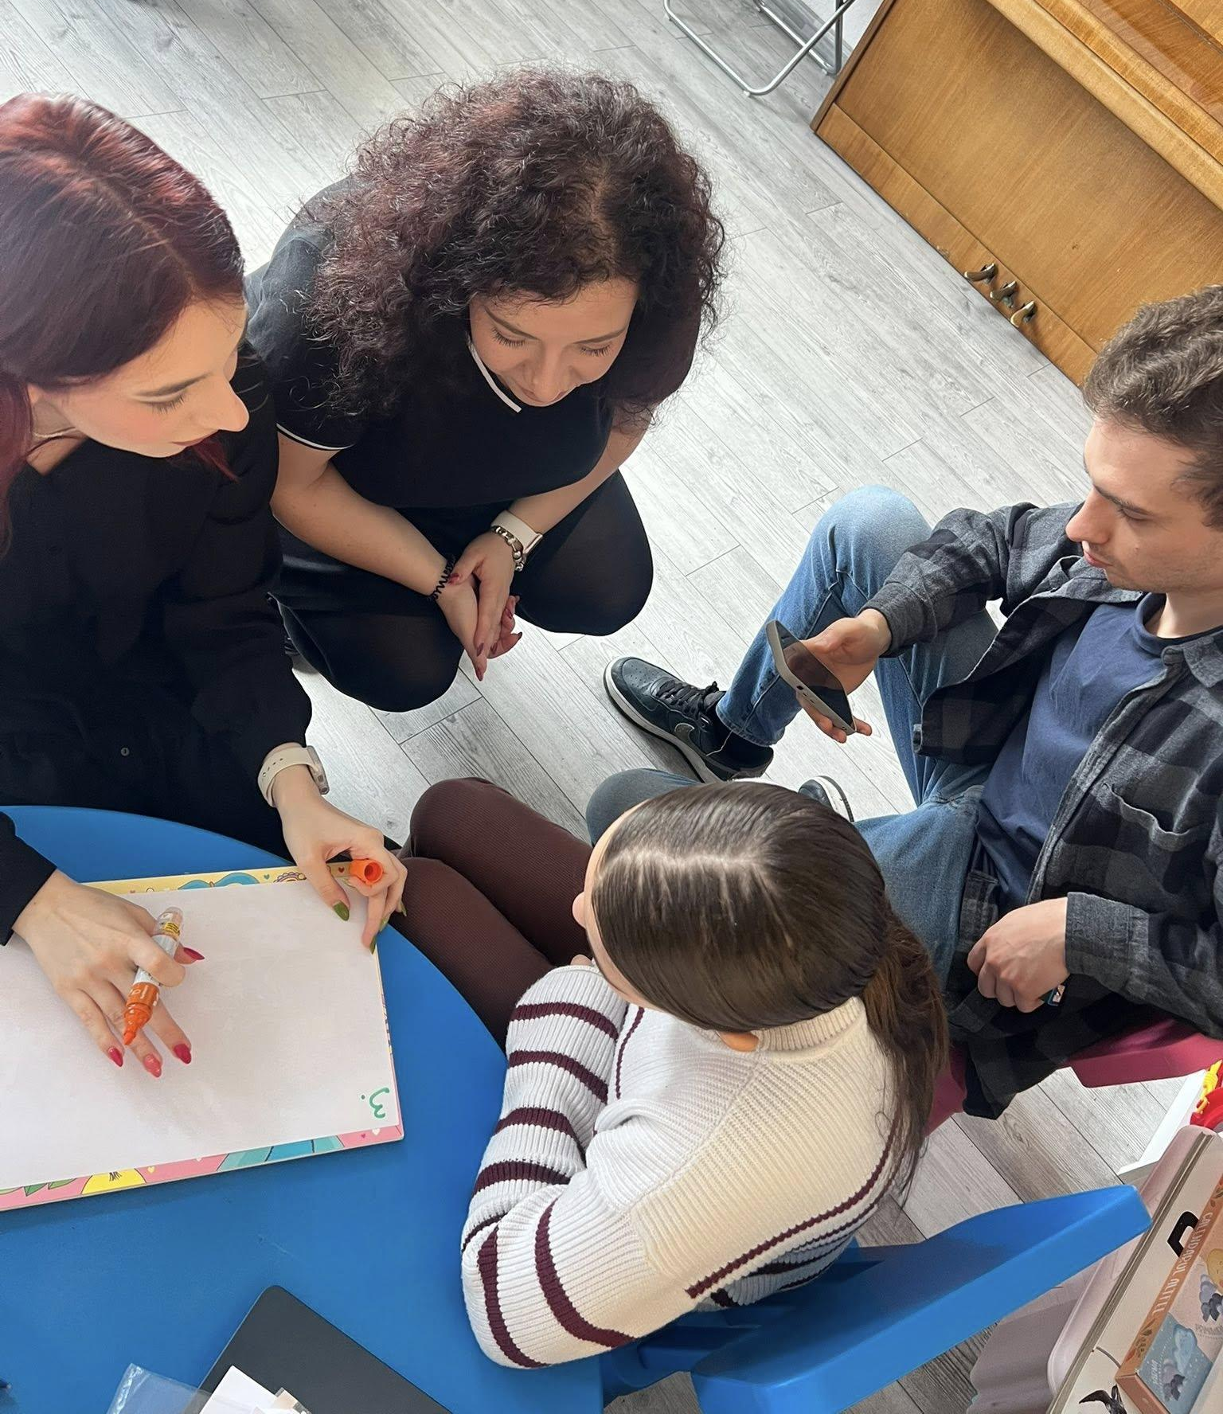

LARC 4: Focus group
The focus group has been implemented on two different groups and so, on different dates, as follows:
FOCUS GROUP 1: Young people aged 18+
It was organized on 19 February 2026, in Pietroșani, bringing together 14 young people (9 in-person and 5 online) to discuss youth participation, civic engagement, and the Future of Europe. Through interactive discussions, participants explored the challenges and opportunities affecting their involvement in democratic processes, highlighting issues such as access to information, education, rural development, and trust in institutions. The activity generated valuable insights and recommendations on how to increase youth participation through local debates, social media, educational initiatives, and stronger communication about European opportunities, contributing directly to the development of the NOTSKIP recommendations and podcast content.
FOCUS GROUP 2: Youth workers
It has been implemented on 22 February 2026, Bucharest, Romania and on 12 February 2026 in Plopeni at Carol I Highschool, bringing together 20 professionals working with young people. The discussion focused on civic participation, democratic inclusion, and the role of education in strengthening citizens' engagement. Participants emphasized the need for dedicated EU education, improved civic learning, stronger support for teachers and youth workers, and innovative approaches combining community activities with digital tools. These focus groups provided practical recommendations for enhancing youth participation, combating apathy, and creating more effective pathways for citizens to contribute to local and European decision-making processes.

COMMUNICATION AND DISSEMINATION LINKS:
IG: https://www.instagram.com/p/DZUkIvRlywu/?igsh=cXYyZmI1cGRvMmcw
FB: https://www.facebook.com/share/p/1CfLgG9Lwk/?mibextid=wwXIfr

PHOTOS:
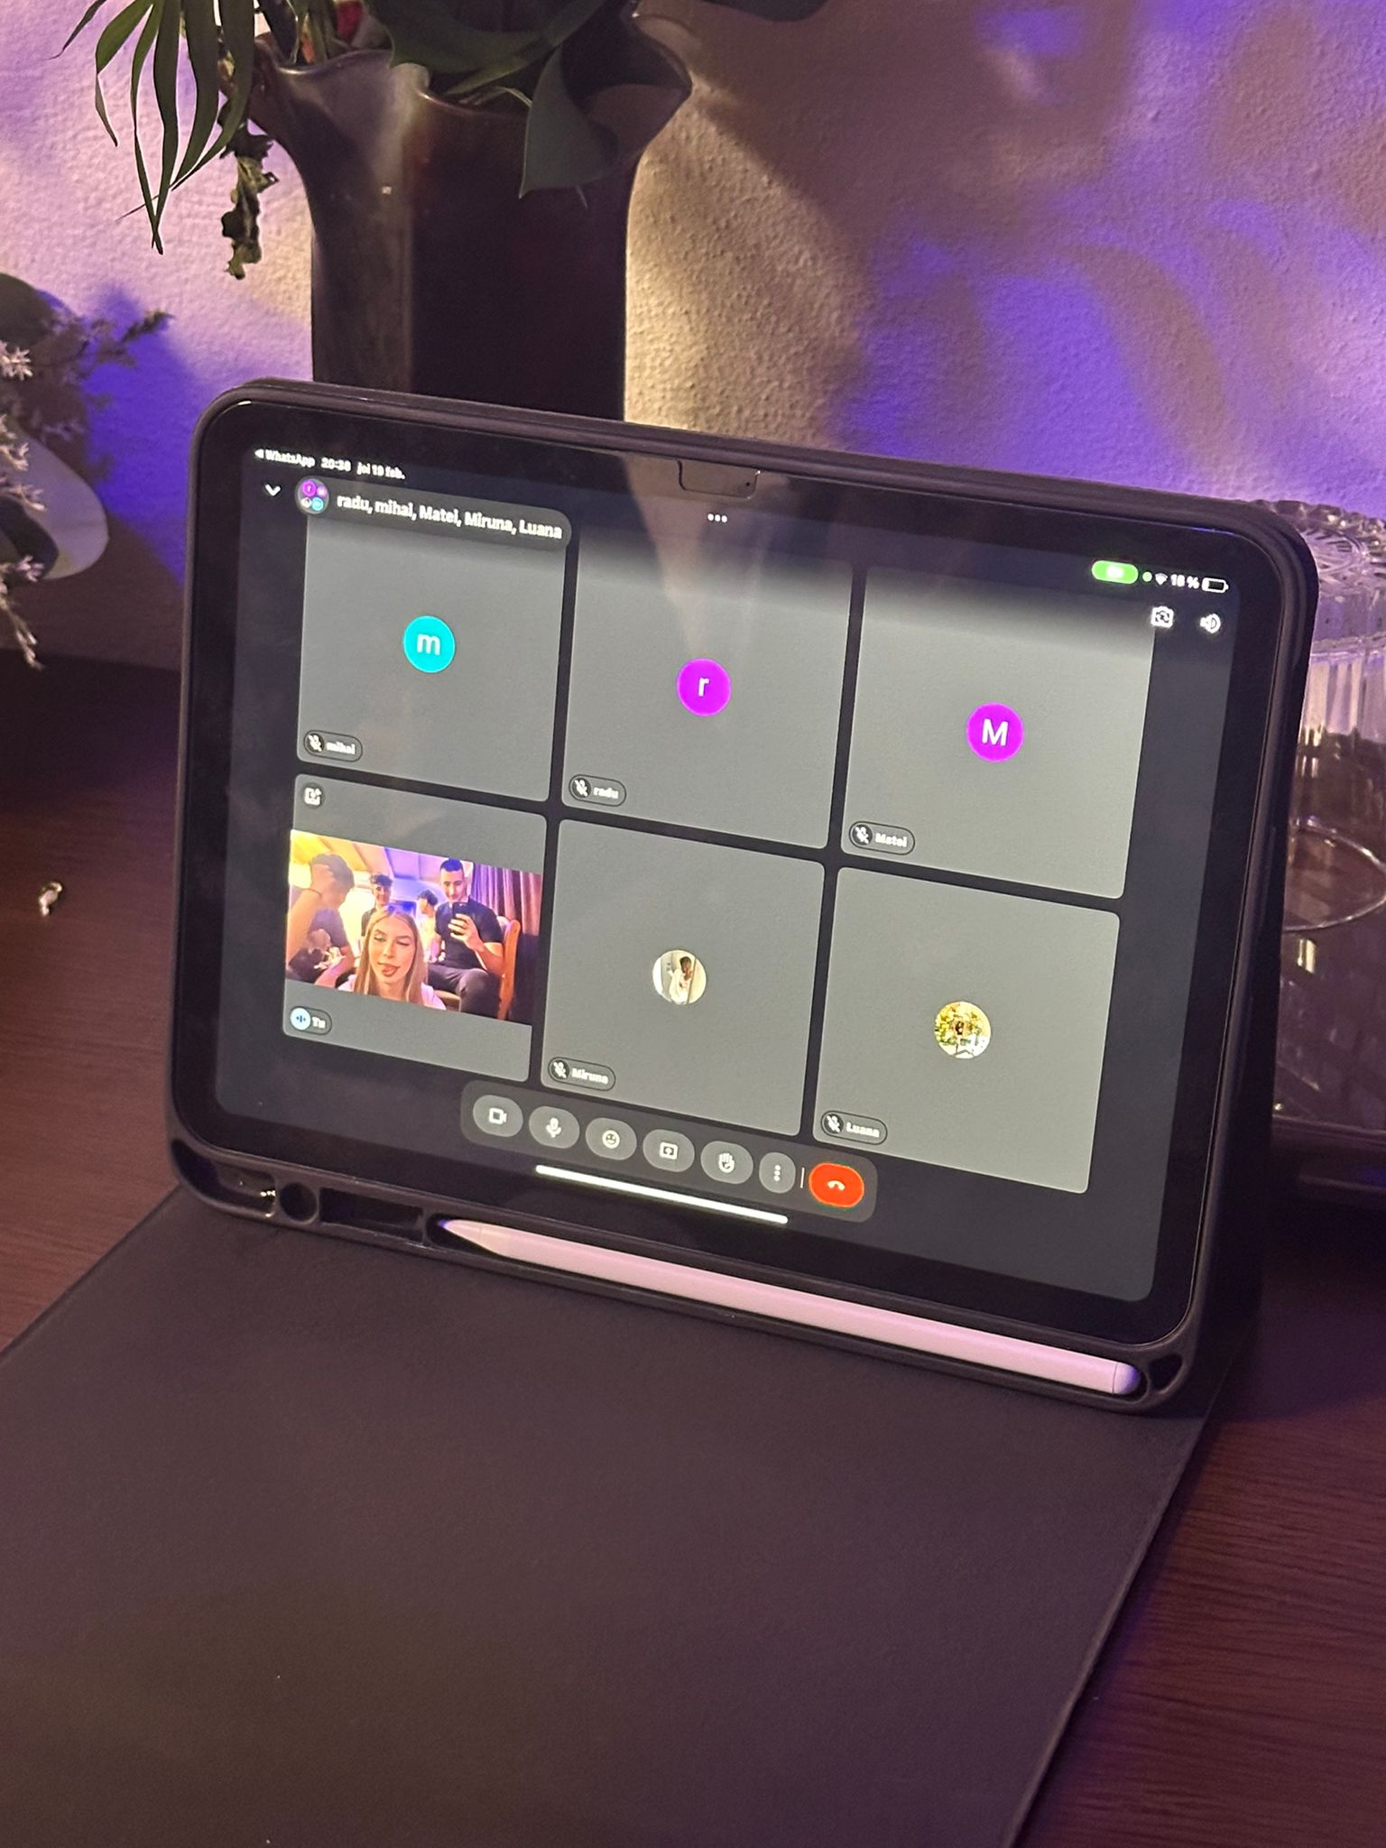
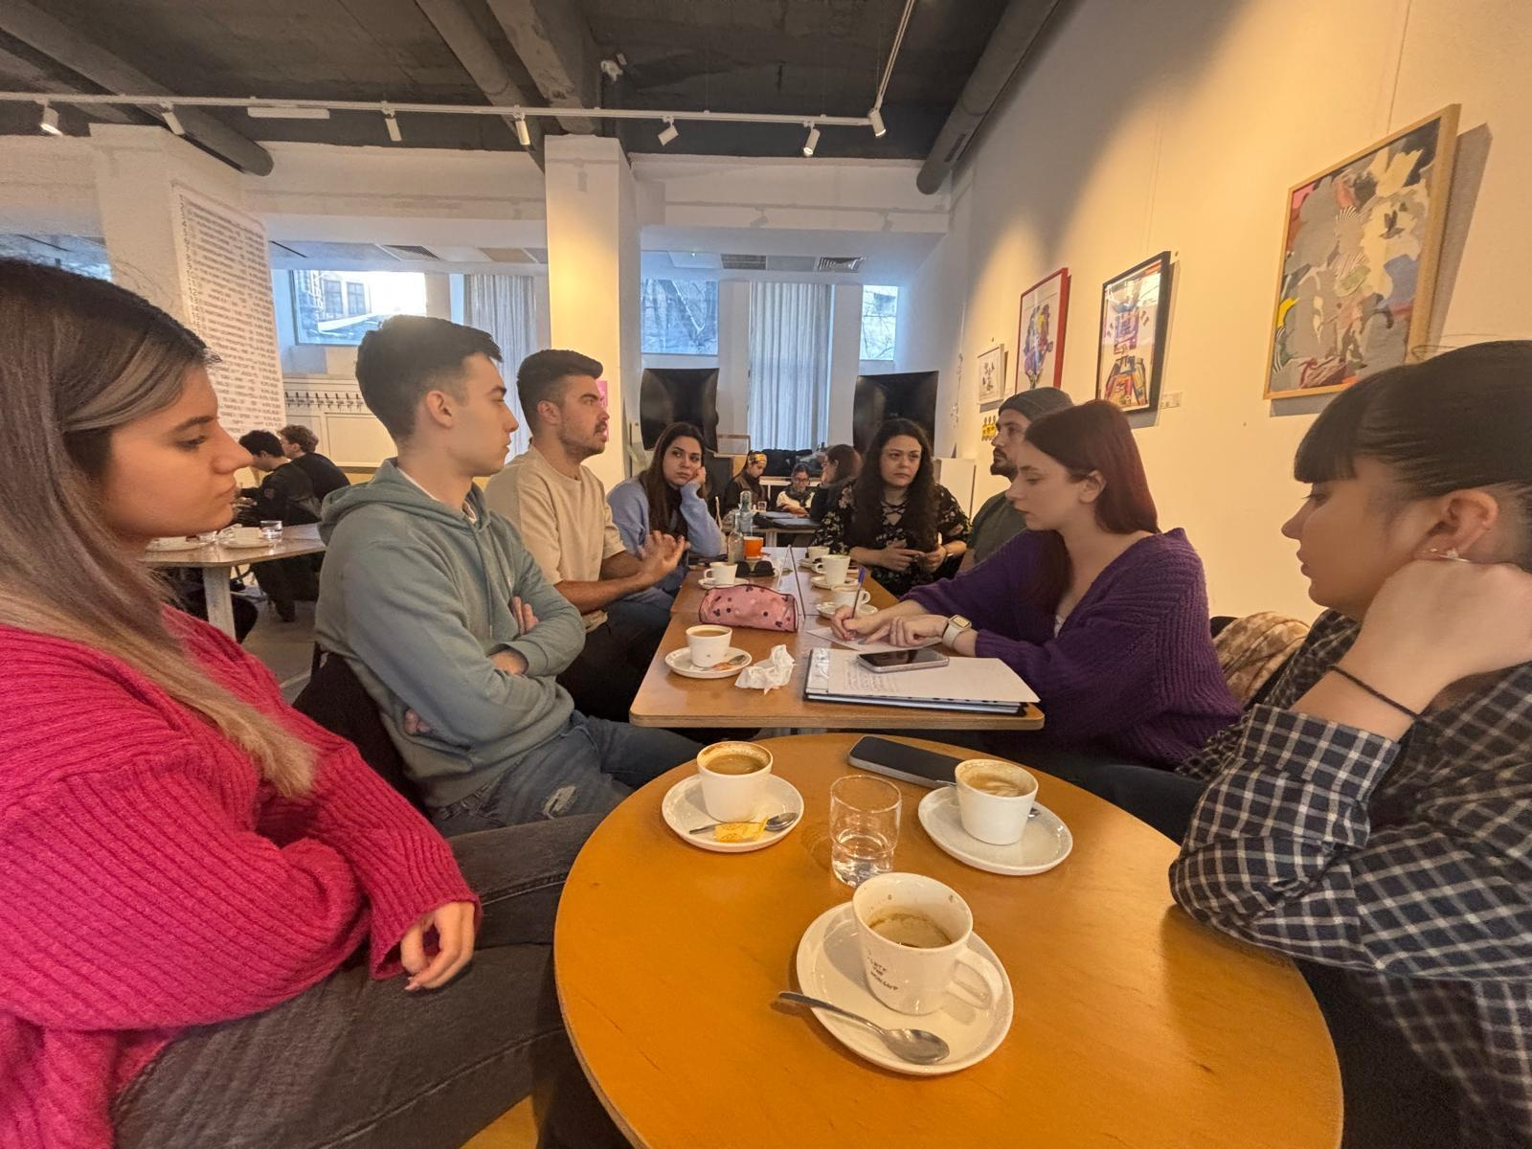
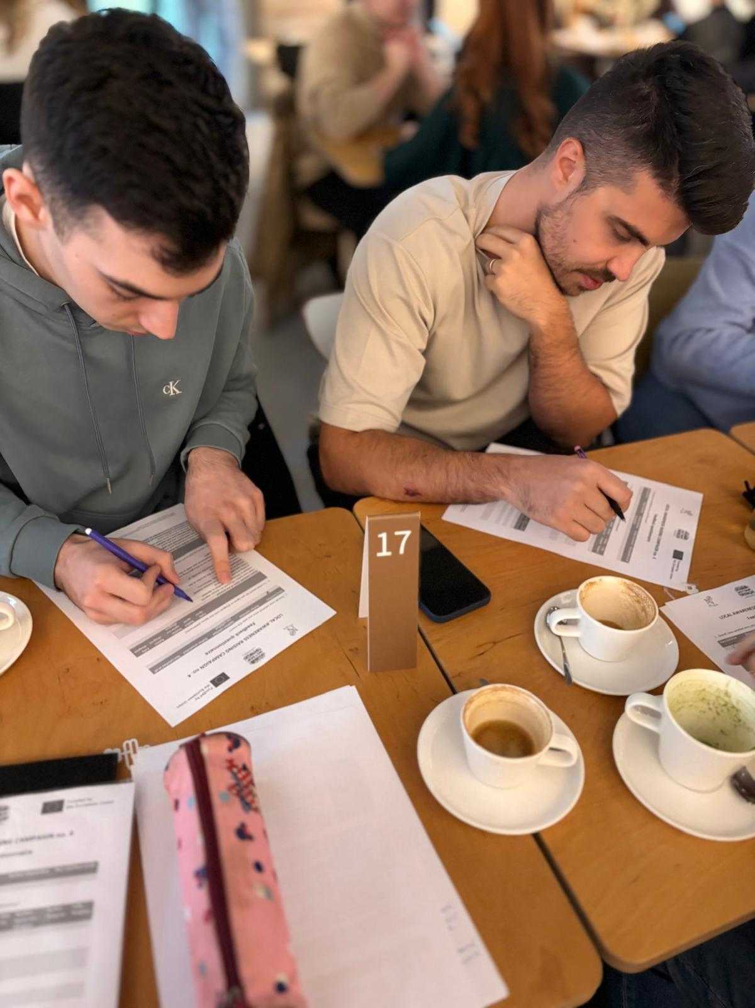

LARC 5: Podcast
As part of the NOTSKIP podcast series, ANA hosted Mr. Bogdan Micu, entrepreneur, investor, active volunteer in local councils at the Municipality of Brasov and Bucharest and volunteer councilor within the Environment Ministry. The episode focused on several of the project's recommendations and explored practical ways to strengthen citizens’ participation in democratic and community life. The discussion highlighted the importance of moving beyond dialogue and turning citizens’ ideas into concrete actions and results. Mr. Micu shared insights from his experience in civic engagement, emphasizing the need for stronger civic education, increased community involvement, and more accessible information about European opportunities. One of the key proposals discussed was the development of a user-friendly and easy to access - digital application that would allow citizens to quickly access information about European Union programmes, funding opportunities, and participation initiatives. The podcast also explored how individuals can become more active in their communities, the role of entrepreneurship and volunteering in creating social impact, and the importance of persistence in achieving meaningful change. Through this conversation, the episode reinforced the NOTSKIP project's objective of empowering citizens to move from awareness to action and to play an active role in shaping their local communities and the future of Europe.
COMMUNICATION AND DISSEMINATION LINKS:
https://youtu.be/xUPY_VzurZE?is=N5zzeDjqO9KcCYTb
​​https://www.facebook.com/share/17i6JK5SbE/?mibextid=wwXIfr
https://www.instagram.com/p/DW3RetDjGOx/?igsh=cWY0czR1dnVod2Ew

PHOTOS:
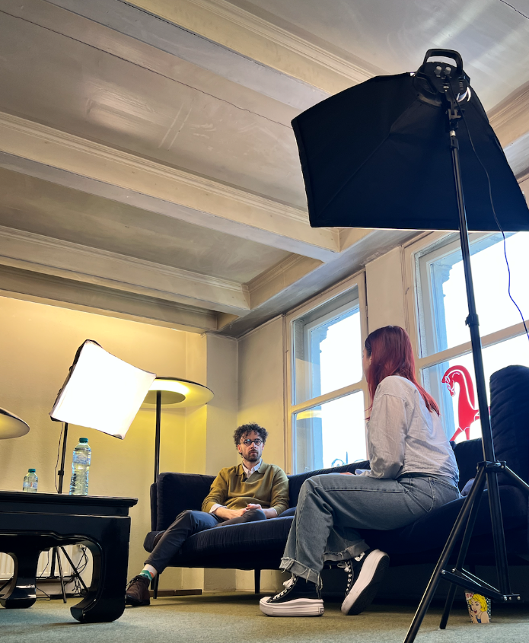
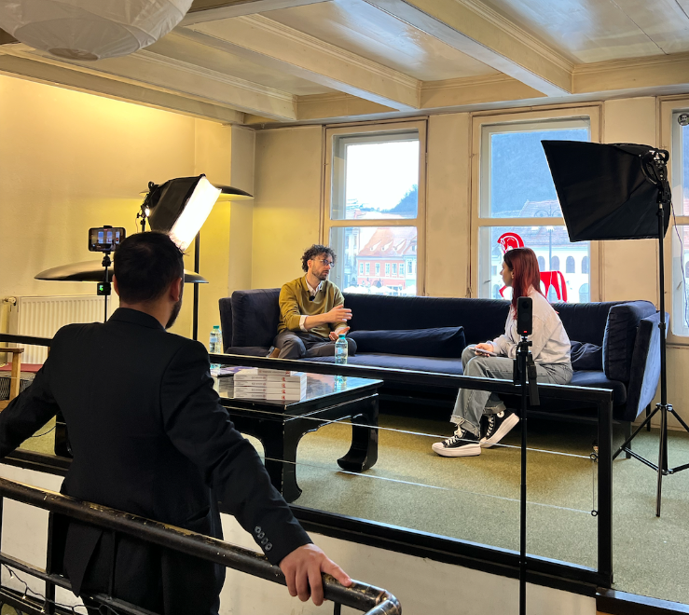
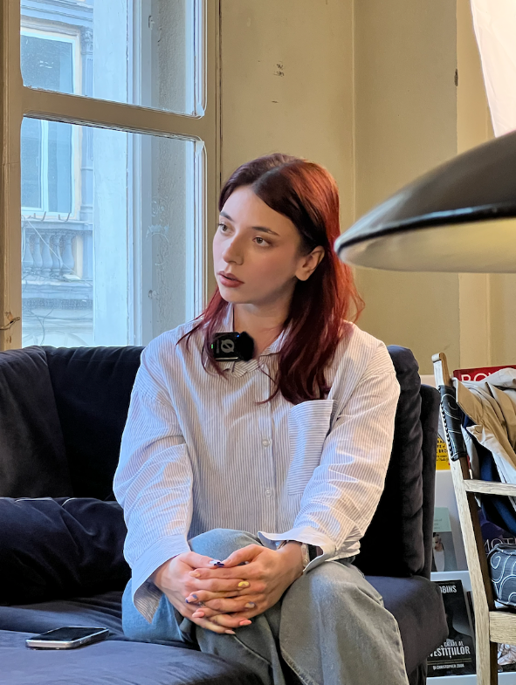

LARC 6: Dissemination event
On 5 June 2026, ANA organized the local dissemination event of the NOTSKIP – Network of Organizations for Promoting Skills for Participation project at Vimo Restaurant in Băicoi, Romania. The event brought together local citizens, educators, representatives of local authorities, civil society organizations, facilitators, and young people interested in civic participation and democratic engagement. Among the participants, students and teachers from Carol I High School in Plopeni were actively involved, contributing to the discussions and learning about the opportunities offered by European projects for active citizenship.
The main objective of the event was to promote and to present the objectives, activities, and achievements of the NOTSKIP project implemented over the last two years. Participants were welcomed with dissemination materials and introduced to the mission and experience of the Nameless Art Association. During the event, project representatives presented the NOTSKIP project, highlighting its goals of strengthening citizens’ participation skills, encouraging dialogue between citizens and decision-makers, and promoting democratic values at both local and European levels. The audience was also informed about the various activities carried out throughout the project, including participatory initiatives, debates, networking activities, and opportunities for civic engagement. A dedicated session focused on the project results and the impact generated within the partner communities. Participants had the opportunity to view project outputs and dissemination materials, gaining a deeper understanding of the project's achievements and long-term benefits.
The event concluded with an open Question & Answer session, allowing participants to exchange ideas, share reflections, and discuss the importance of citizen involvement in democratic processes. A feedback session was organized at the end of the meeting, providing valuable insights regarding the relevance and impact of the project activities.
COMMUNICATION AND DISSEMINATION LINKS:
IG: https://www.instagram.com/p/DZPaqncl1to/?igsh=bmszdjBvNmUxZms1
FB: https://www.facebook.com/share/p/1EgRJqRTsX/?mibextid=wwXIfr

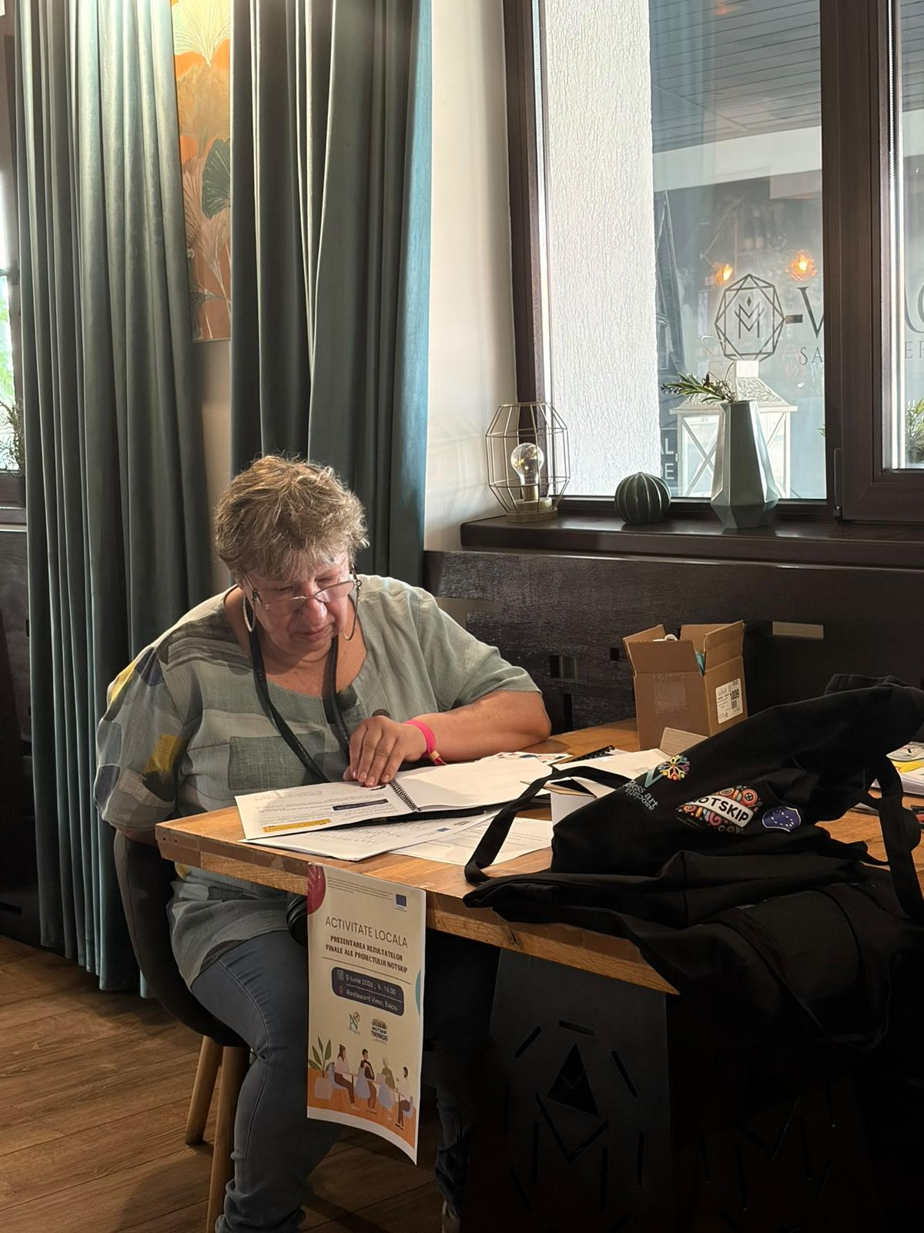
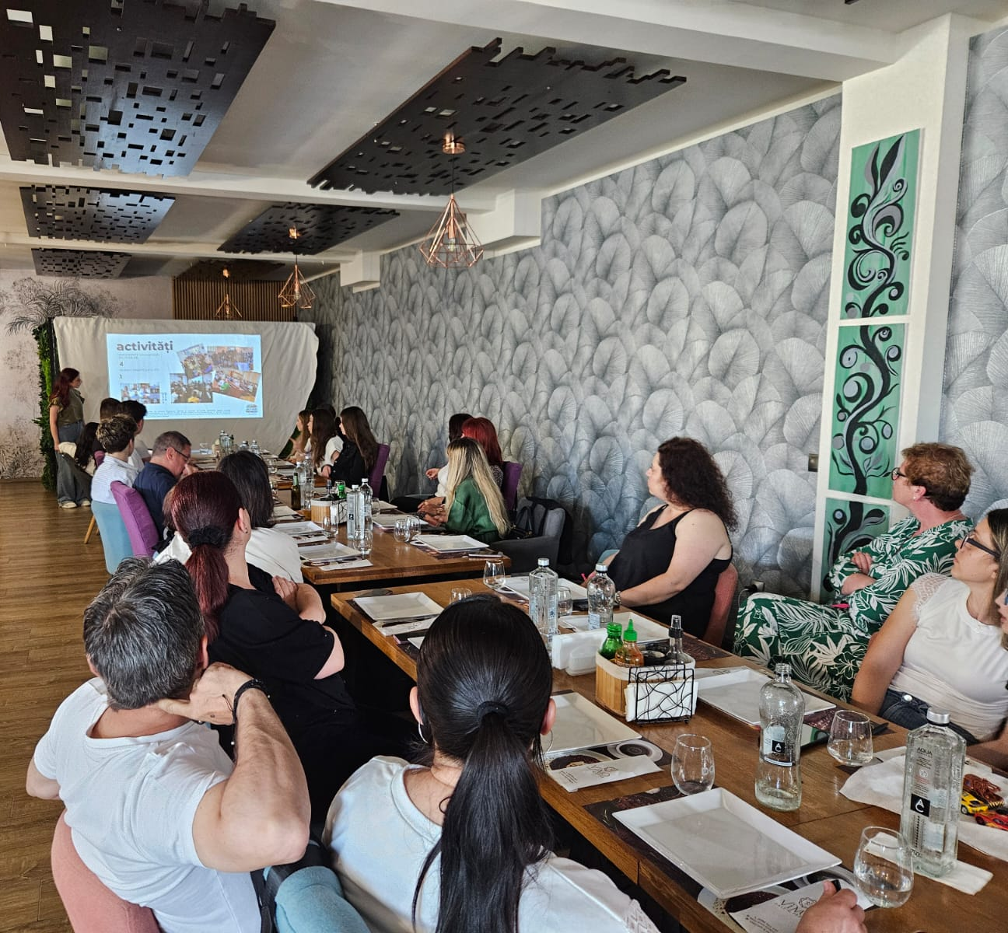
PHOTOS:

Institutions involved: For achieving the goals of these activities and for a right implementation, we have involved the following public/private institutions: Municipality of Ploiesti, Carol I highschool, Carturesti library and With Hope Center

HISTORY OF CHANGES
VERSION | PUBLICATION DATE | CHANGE
1.0 | 01.04.2022 | Initial version (new MFF).

