EVENT DESCRIPTION SHEET
(To be filled in and uploaded as deliverable in the Portal Grant Management System, at the due date foreseen in the system.
Please provide one sheet per event (one event = one workpackage = one lump sum).)
PROJECT
Participant: | [2] - [Lokalna Grupa Działania “Dolina Rzeki Grabi”]
PIC number: | [902060425]
Project name and acronym: | [Network of organizations for Promoting Skills for Participation ] — [NOT SKIP]

EVENT DESCRIPTION
Event number: | [Work Package 7]
Event name: | Local Awareness Raising Campaigns in Poland (LARC)]
Type: | [desk research, street debate, round table, focus groups, podcast, local dissemination]
In situ/online: | [in-situ]
Location: | [Poland], [Łask, Zelów, Łódź]
Date(s): | [Desk research: 17 March 2025;  Street debate: 30 September 2025;  Round table: 21 November 2025;  Focus groups: 26 February 2026;  Podcast: 4 May 2026;  Local dissemination: 15 June 2026]
Website(s) (if any): | https://dolinagrabi.pl/  https://www.facebook.com/profile.php?id=100064277666371  https://www.instagram.com/lgd.dolina_rzeki_grabi/
Participants
Female: | 96
Male: | 29
Non-binary: | 0
From country 1 [Poland]: | 125
Total number of participants: | 125 | From total number of countries: | 1
Description
Provide a short description of the event and its activities.
LARC 1: Desk research
The desk research activity involved the identification and analysis of two good practices illustrating how cultural and educational initiatives can strengthen democracy, civic engagement, and active citizenship in Poland.
The first practice was the Association “Aktywne Kobiety” (Active Women) based in Sosnowiec. The organisation implements a wide range of long-term activities focused on equal opportunities, social inclusion, and civic participation. Its work includes leadership and empowerment programmes for women, civic education activities for different age groups, cultural and media initiatives such as film discussions and documentaries, as well as international cooperation projects. The practice demonstrates how community-based education and empowerment can increase civic participation, strengthen local leadership, and promote democratic values at grassroots level.
The second practice was the Democracy Festival “Prism” held in Gdańsk at the European Solidarity Centre. This one-day event combines civic education with cultural and artistic activities, including film screenings, workshops, debates, and discussions with experts, policymakers, activists, and young people. The festival promotes active citizenship by creating an open space for dialogue on democracy, human rights, and contemporary social challenges, particularly targeting youth engagement.
Both practices show how combining education, culture, and participatory methods can effectively support civic awareness, democratic engagement, and social inclusion. They also provided valuable input for developing further project activities based on bottom-up approaches and active participation of citizens at local and European level.
COMMUNICATION AND DISSEMINATION LINKS:
https://www.instagram.com/p/DJQ-CJQsCws/?img_index=1
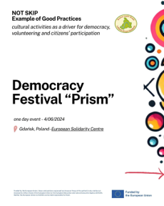
LARC 2: Street debate
The Street Debate “How can we live together in peace” was organised on 30/09/2025 in Zelów, Poland by LAG “Dolina Rzeki Grabi” at the Comprehensive School Complex in Zelów and involved 60 participants.
Originally planned as an outdoor activity, the event was moved indoors due to heavy rainfall, with students’ thematic posters displayed in school corridors, creating a space for reflection and discussion.The debate brought together students, younger pupils, teachers and parents, enabling an intergenerational exchange on peaceful coexistence, mutual respect and the importance of dialogue in everyday life. Participants discussed key values such as respect, empathy, communication, tolerance and openness, emphasising the role of active listening, rejection of hate speech and the idea that peace starts with individual attitudes and responsibility.
Despite the change of format, the activity was successfully implemented and strengthened community engagement and dialogue across different age groups.
COMMUNICATION AND DISSEMINATION LINKS:
https://www.facebook.com/permalink.php?story_fbid=pfbid027o3tAkubrEXbjRkUh4vK3PJXB5JZe37a2qYhRUueRDqBCBcx7LSLnhrvDapaXoGDl&id=100064277666371
https://dolinagrabi.pl/2025/10/01/debata-uliczna-how-can-we-live-together-in-peace/
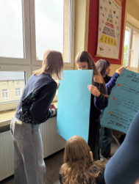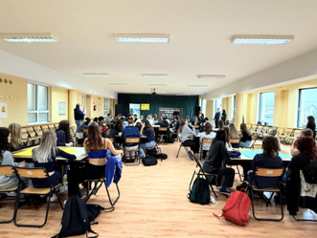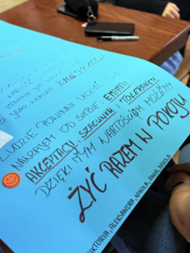
LARC 3: Round table
On 21 November 2025 in Łask, Poland, a Round Table discussion was organised bringing together local stakeholders, representatives of local authorities, youth representatives, and active citizens to discuss ways of strengthening democratic participation and civic engagement at the local and European levels. Following an introduction to the project and the presentation of activities carried out by the Youth City Council, participants engaged in a structured dialogue facilitated by project-trained moderators.
The discussion focused on citizens’ contribution to the Future of Europe, effective tools and methods for civic participation, the role of local decision-makers in fostering engagement, and key barriers to participation such as disinformation, limited civic education, digital exclusion, and low trust in institutions. Participants exchanged experiences, shared successful local practices, and reflected on challenges affecting citizen involvement in decision-making processes.
The activity concluded with collaborative work on recommendations aimed at strengthening youth participation, improving communication between institutions and residents, and promoting inclusive participation mechanisms. The Round Table provided a valuable space for dialogue, mutual learning, and the development of practical ideas to enhance democratic engagement within the local community.
COMMUNICATION AND DISSEMINATION LINKS:
https://www.facebook.com/permalink.php?story_fbid=pfbid06m6UUiTVc8xXDnNTK1T4LwNP7NByZxSAjiAmaMFzPJKHxWurukxE5jrrorKvTeS8l&id=100064277666371
https://www.facebook.com/permalink.php?story_fbid=pfbid0WhbKTSA6u9TdBbRBhPGyWkdygky3vDRzHXz2wSXgSa3nGT8MSJExQ589fpUttf2Cl&id=100064277666371
https://dolinagrabi.pl/2025/11/18/round-table-razem-dla-demokracji-w-ue/
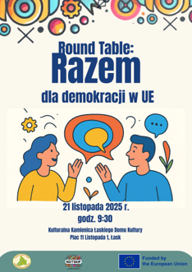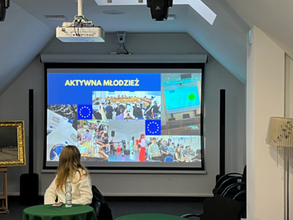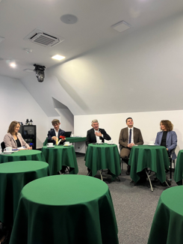
LARC 4: Focus groups
On 26 February 2026, two Focus Group sessions were organised at the Comprehensive School Complex in Zelów, Poland, bringing together 24 participants, including youth workers, educators, trainers, teachers, and young people aged 18–30. The activity aimed to explore how citizens engage in social and political life and how young people can contribute to shaping the Future of Europe in line with the objectives of the NOTSKIP project. The sessions also sought to deepen participants’ understanding of EU participatory tools, identify grassroots initiatives that can strengthen civic engagement at the local level, and collect input for the project’s final recommendations, local campaigns, and podcast content.
The first focus group gathered youth workers, educators, and teachers who shared experiences from their professional practice and discussed successful approaches to fostering youth participation. The discussion highlighted the importance of long-term cooperation between schools, NGOs, and public institutions, while also identifying challenges such as limited resources, low motivation among young people, and insufficient awareness of European participatory mechanisms.
The second focus group involved young people aged 18–30, who reflected on their experiences, motivations, and expectations regarding civic engagement. Participants discussed opportunities offered by local and European initiatives, barriers such as lack of information, limited influence on decision-making, and low trust in institutions, as well as the importance of accessible and youth-friendly participation formats.
The focus groups resulted in a set of recommendations aimed at strengthening youth participation, improving communication about civic opportunities, supporting local partnerships, and creating more effective mechanisms for involving citizens in decision-making processes at both local and European levels.
COMMUNICATION AND DISSEMINATION LINKS:
https://www.facebook.com/permalink.php?story_fbid=pfbid0MmHGfaBira39WshdN8wS6i7hNEDxmEoRGUmDTi5EwJ4HYonHyu8czJB3WkkwwMcJl&id=100064277666371
https://www.facebook.com/permalink.php?story_fbid=pfbid0SXFjaUm71Gnr78WAzHJHVdC8eFiCMpDmmpSHtqwJLm6rEBp9HCSRc2Lf8anC7gPml&id=100064277666371
https://dolinagrabi.pl/2026/02/24/focus-groups-wspolna-rozmowa-o-przyszlosci/
https://dolinagrabi.pl/2026/02/27/focus-groups-relacja-z-wydarzenia/
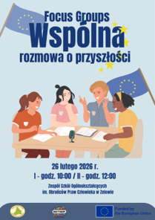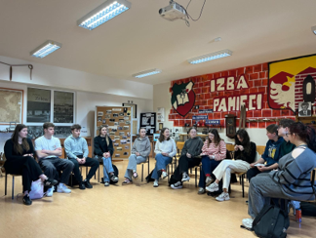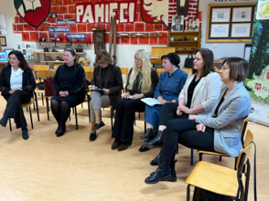

LARC 5: Podcast
On 4 May 2026, a podcast interview was conducted in Łódź, Poland, at the constituency office of Member of the European Parliament Dariusz Joński. The discussion was facilitated by Julita Niemiec and focused on the final NOTSKIP Recommendations, which had been previously shared with the MEP.
The conversation examined the relevance of the recommendations in the Polish context and their alignment with citizens’ real experiences. It addressed key issues such as trust in institutions, the effectiveness of public consultations, and the level of awareness of EU participatory tools. The discussion also explored opportunities and barriers for civic engagement in Poland, including the need to move from one-off consultations towards more permanent participation mechanisms involving citizens in decision-making processes.
Particular attention was given to digital exclusion and the importance of ensuring accessible participation opportunities for all groups, as well as the potential of hybrid models combining online and face-to-face engagement. The role of local authorities, schools, and civil society organisations in supporting civic awareness and participation was also highlighted.
The podcast contributed to the NOTSKIP project objective of strengthening the link between citizens’ perspectives and European-level decision-making, and of promoting more inclusive and effective participatory tools for engaging citizens in shaping the Future of Europe.
COMMUNICATION AND DISSEMINATION LINKS:
https://www.facebook.com/permalink.php?story_fbid=pfbid0iB1WtHkuTGjwyXKY17VrZCdK39eW8h3wb9CKfvxJC6hZKrsoAmkoXQDJWbxiygiSl&id=100064277666371
https://dolinagrabi.pl/2026/05/20/czy-glos-obywateli-naprawde-ma-znaczenie-rozmowa-z-dariuszem-jonskim/
https://www.youtube.com/watch?v=DlQb64bs5Tg&t=9s

LARC 6: Local Dissemination
On 15 June 2026, a local dissemination event was organised in Zelów, Poland, at the Complex of General Secondary Schools named after human rights defenders. The activity gathered 25 participants, including students, school management, teachers, project facilitators, representatives of the Municipal Department of Education, the Chairperson of the City Council, and members of the local community, ensuring an intergenerational exchange of perspectives on civic engagement and democratic participation.
The event aimed to present the results of the NOTSKIP project and discuss their potential application in educational and local community settings. Following the introduction of the project and its international partnership, participants were presented with the main outcomes, including the competences developed by facilitators and the methods used to foster civic participation.
A dedicated discussion focused on the transferability of project results and their relevance for strengthening civic education, youth engagement, and cooperation between schools and local authorities. Participants exchanged views on how the project’s approaches could support more active participation of young people in local decision-making processes.
The meeting concluded with a question-and-answer session and a discussion on future initiatives promoting democratic participation. Evaluation feedback collected at the end of the event indicated a very positive assessment of the activity, particularly in terms of content clarity, organisation, and its contribution to participants’ understanding of the project outcomes.

COMMUNICATION AND DISSEMINATION LINKS:
https://www.facebook.com/permalink.php?story_fbid=pfbid02HBa8qG1thgGNQu2K8hw4hNAZ4aLDPx4NnnN6hGm1v56NM6DAroMakjp6oG4NkhGPl&id=100064277666371
https://dolinagrabi.pl/2026/06/16/projekt-not-skip-i-lokalne-wydarzenie-upowszechniajace/

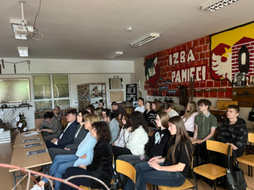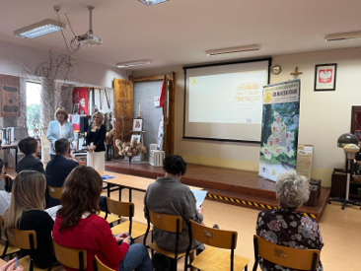

Institutions involved
Across all project activities, the implementation involved a range of public, educational, and civil society stakeholders. These included the Municipality of Zelów and the Municipality of Łask (represented by local authorities), the Youth City Council of Zelów, the Complex of General Secondary Schools in Zelów named after Human Rights Defenders, the Social Economy Support Centre (OWES) – Institute of Civic Affairs (Instytut Spraw Obywatelskich), as well as representatives of local decision-making bodies and educational institutions.
Their participation ensured cross-sectoral cooperation between local authorities, youth representatives, educators, and civil society organisations, contributing to intergenerational dialogue and the development of civic participation at local level.

HISTORY OF CHANGES
VERSION | PUBLICATION DATE | CHANGE
1.0 | 01.04.2022 | Initial version (new MFF).

